How to couple pore water pressure to simulate triaxial test using Cam-clay model
Here are some questions I want to ask. Thanks!
Problem description:
We want to simulate the behavior of soil sample from a trialxial test. The cam-clay model here is applied to simulate the soil material. Besides, the pore water pressure is a concerning issue in this simulation. So, we need to couple the pore water pressure in our model.
The simulation is based on an existing example named “Isotropic Compression” in models library.
In order to consider the pore water pressure, we add “Darcy’s law” physics into the model as shown in fig. 1.
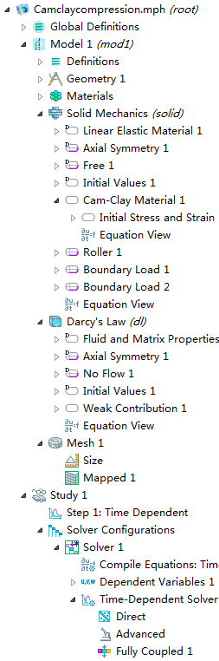
Fig.1：physics and study in the model
In Cam-clay material’s page, the pore water pressure from physics of darcy’s law is set as shown in fig.2 .
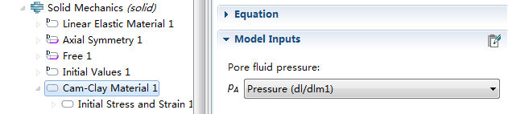
Fig.2
From the cam-clay’s “equation view”, we find that the stress contains the term of pore water pressure. Just as the following:
solid.Sl11=-(solid.Sil11+solid.Sil22+solid.Sil33)/3-solid.pf-solid.Pc0*exp(-((1+solid.evoid0)*(solid.eel11+solid.eel22+solid.eel33)+solid.evoid0-solid.Nvoid+solid.lambdaComp*log(solid.Pc0/solid.prefVCL))/solid.kappaSwelling)+2*solid.G*(solid.eel11-(solid.eel11+solid.eel22+solid.eel33)/3)+solid.Sil11 ,
where solid.pf denotes the pore water pressure.

In darcy’s law physics, a “weak contribution” for the domain is added.
-d(solid.evol,TIME)*rhof*test(p)
As fig3. showing. The pore water pressure is coupled into the model with this step.
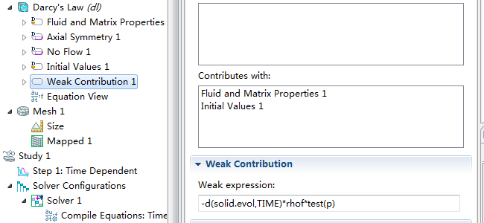
Fig. 3

Parameters setting:
Showed in Fig.4, the initial stress is modified as 400[kPa].
The calculated initial void ration e0 is 0.6556. As fig5 showing:
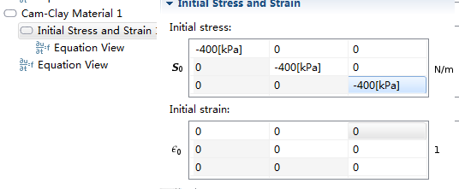
Fig.4
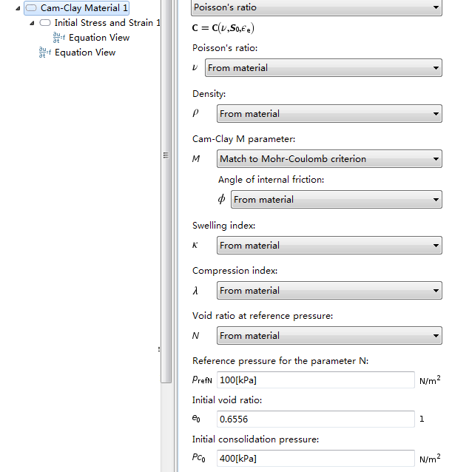
Fig 5
The above settings are to make sure the state of stress in the yield surface.
The boundary conditions are shown in fig6:
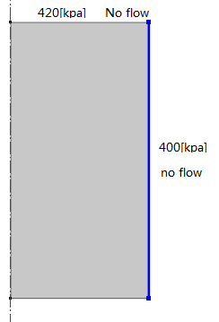
Fig.6 boundary conditions

The simulation with the above settings cannot run successfully. And the errors will be tipped as the following.
Failed to find consistent initial values.
Failed to compute elastoplastic strain variables.
Last time step is not converged.
If setting the top surface of the soil sample drained, i.e. p=0, another error is prompted as following:
Failed to find consistent initial values.
Error in elPlastic element.
Lambda non positive for plastic point
Last time step is not converged.

Our questions are:
(1) Is the above procedure to couple the pore water pressure with Cam-clay model to simulate triaxial test correct?
(2)What the meanings of the above error information are?
(3) Is there any similarly example to provide to us?

