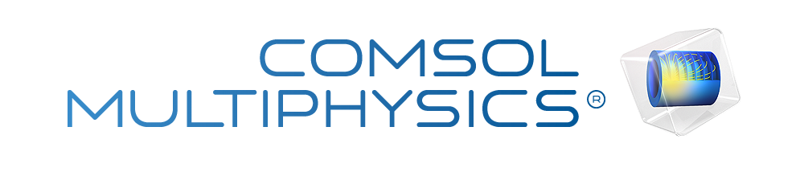

Untitled
Report date | Jun 25, 2015 2:15:11 PM

Contents
1. Global Definitions
1.1. Parameters 1
2. Component 1
2.1. Definitions
2.2. Geometry 1
2.3. Materials
2.4. Electroanalysis
2.5. Laminar Flow
2.6. Mesh 1
3. Study 1
3.1. Cyclic Voltammetry
3.2. Solver Configurations
4. Study 2
4.1. Stationary
4.2. Solver Configurations
5. Results
5.1. Data Sets
5.2. Plot Groups

- Global Definitions
Date | Jun 25, 2015 1:49:01 PM

Global settings
Name | Cv channel mine 6ml Cplane.mph
Path | C:\Users\tre-group-pc\Desktop\comsol\Cv_channel_mine_6ml_Cplane.mph
COMSOL version | COMSOL 5.1 (Build: 136)
Unit system | SI

Used products
COMSOL Multiphysics
Electrochemistry Module

  - Parameters 1
Parameters
Name | Expression | Value | Description
V_f | 6[ml/min] | 1E−7 m³/s | volume Inflow rate
A | 4[mm^2] | 4E−6 m² | Inlet Area
v_in | V_f/A | 0.025 m/s | linear Flow Rate
D | 6.5e-6[cm^2/s] | 6.5E−10 m²/s | Diff. Coe
C_in | 0.95[mmol/L] | 0.95 mol/m³ | Inflow concentration
T | 298[K] | 298 K | Temp.
D2 | 7e-6[cm^2/s] | 7E−10 m²/s | Diff. Coe2
H | 1[mm] | 0.001 m
V_0 | 0.75*(V_f/(K*d)) | 0.0375 m/s
d | 0.4[cm] | 0.004 m
Re | V_f/(0.01*d) | 0.0025 m²/s
V_m | 2*V_0/3 | 0.025 m/s
K | H/2 | 5E−4 m
E_app | 0[V] | 0 V

- Component 1
Date | Jan 23, 2015 10:28:04 AM

Component settings
Unit system | SI
Geometry shape order | automatic

  - Definitions
    - Component Couplings

Integration 1
Coupling type | Integration
Operator name | intop1

Source selection
Geometric entity level | Boundary
Selection | No boundaries

    - Coordinate Systems

Boundary System 1
Coordinate system type | Boundary system
Tag | sys1

Coordinate names
First (t1) | Second (t2) | Third (n)
t1 | t2 | n

Settings
Description | Value
Create first tangent direction from | Global Cartesian

  - Geometry 1
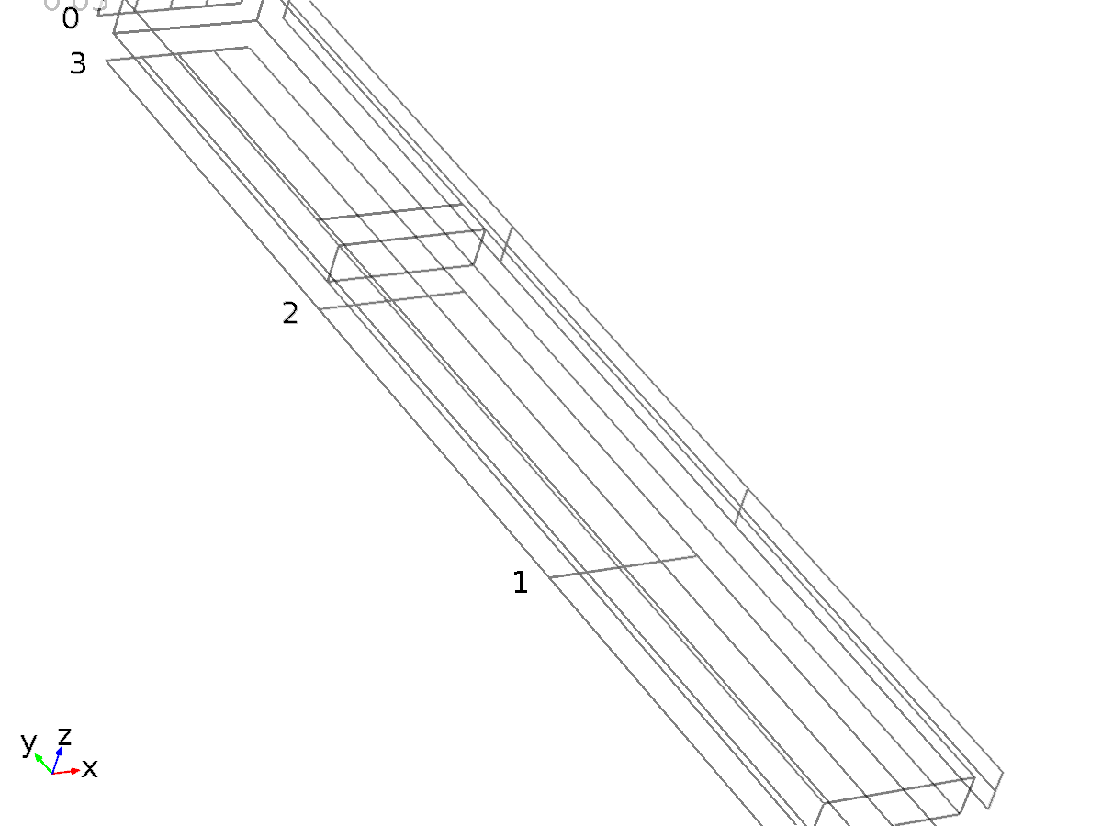
Geometry 1
Units
Length unit | cm
Angular unit | deg

Geometry statistics
Description | Value
Space dimension | 3
Number of domains | 2
Number of boundaries | 12
Number of edges | 23
Number of vertices | 14

    - Block 1 (blk1)
Position
Description | Value
Position | {0, 0, 0}

Axis
Description | Value
Axis type | z - axis

Size and shape
Description | Value
Width | 0.4
Depth | 3
Height | 0.1

Layers
Description | Value
Layers

    - Work Plane 1 (wp1)
Unite objects
Description | Value
Unite objects | On

Plane Geometry (wp1)

Rectangle 1 (r1)
Position
Description | Value
Position | {0, 2}
Layers

Size
Description | Value
Width | 0.4
Height | 0.1

    - Work Plane 2 (wp2)
Settings
Description | Value
Plane | zx - plane

Unite objects
Description | Value
Unite objects | On

Visualization
Description | Value
View work plane geometry in 3D | On

Plane Geometry (wp2)

Rectangle 1 (r1)
Position
Description | Value
Position | {0, 0}
Layers

Size
Description | Value
Width | 0.1
Height | 0.4

  - Materials
    - Water
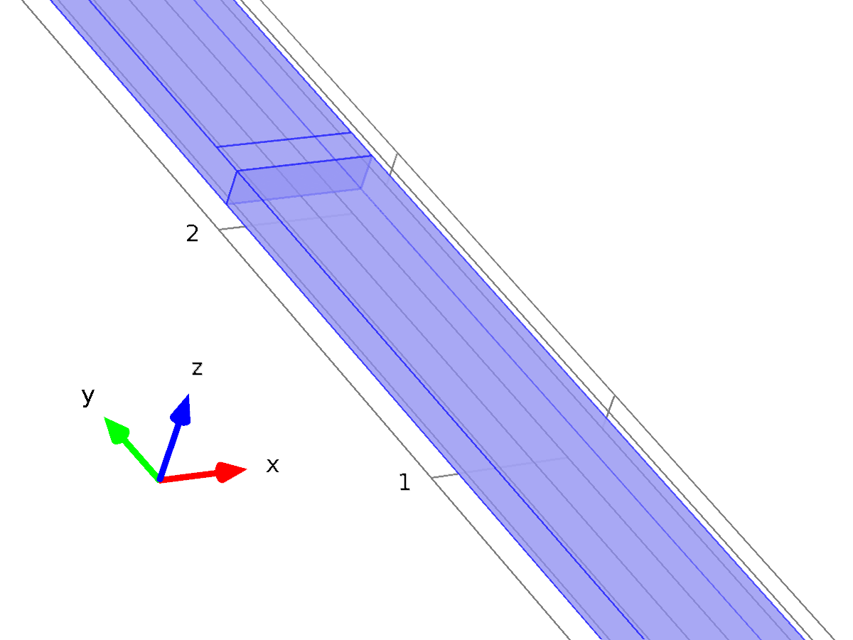
Water
Selection
Geometric entity level | Domain
Selection | Domains 1–2

Material parameters
Name | Value | Unit
Dynamic viscosity | eta(T[1/K])[Pa*s] | Pa*s
Density | rho(T[1/K])[kg/m^3] | kg/m^3

Basic Settings
Description | Value
Dynamic viscosity | eta(T[1/K])[Pa*s]
Ratio of specific heats | 1.0
Electrical conductivity | {{5.5e-6[S/m], 0, 0}, {0, 5.5e-6[S/m], 0}, {0, 0, 5.5e-6[S/m]}}
Heat capacity at constant pressure | Cp(T[1/K])[J/(kg*K)]
Density | rho(T[1/K])[kg/m^3]
Thermal conductivity | {{k(T[1/K])[W/(m*K)], 0, 0}, {0, k(T[1/K])[W/(m*K)], 0}, {0, 0, k(T[1/K])[W/(m*K)]}}
Speed of sound | cs(T[1/K])[m/s]

Functions
Function name | Type
eta | Piecewise
Cp | Piecewise
rho | Piecewise
k | Piecewise
cs | Interpolation

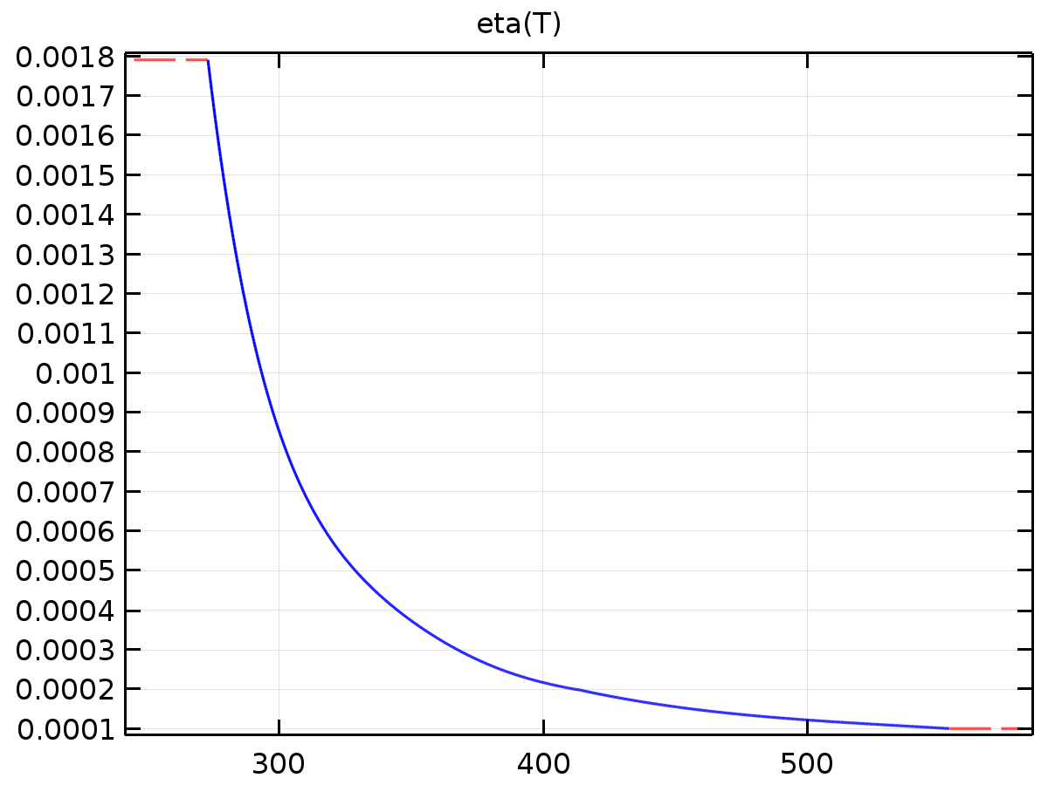
eta
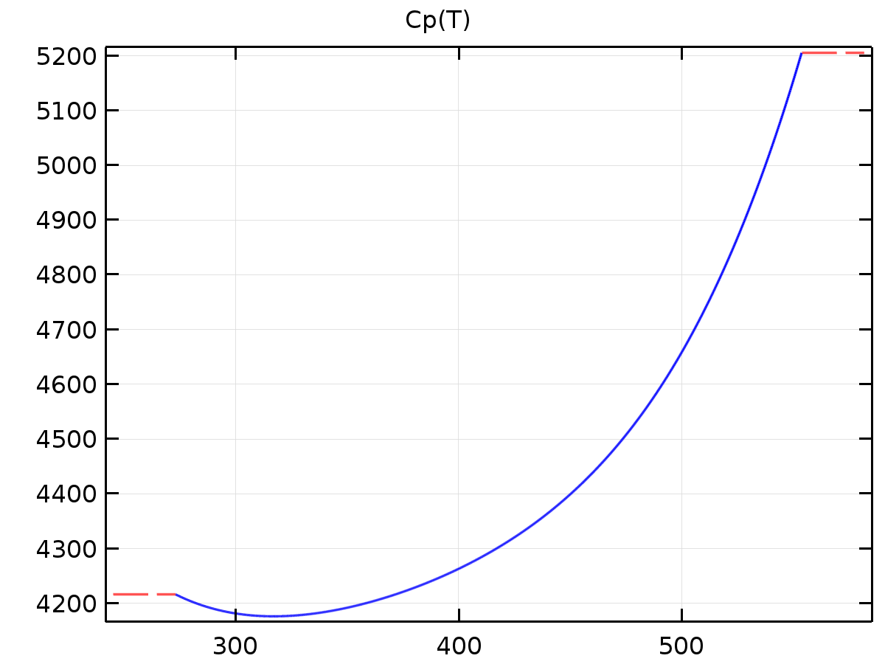
Cp
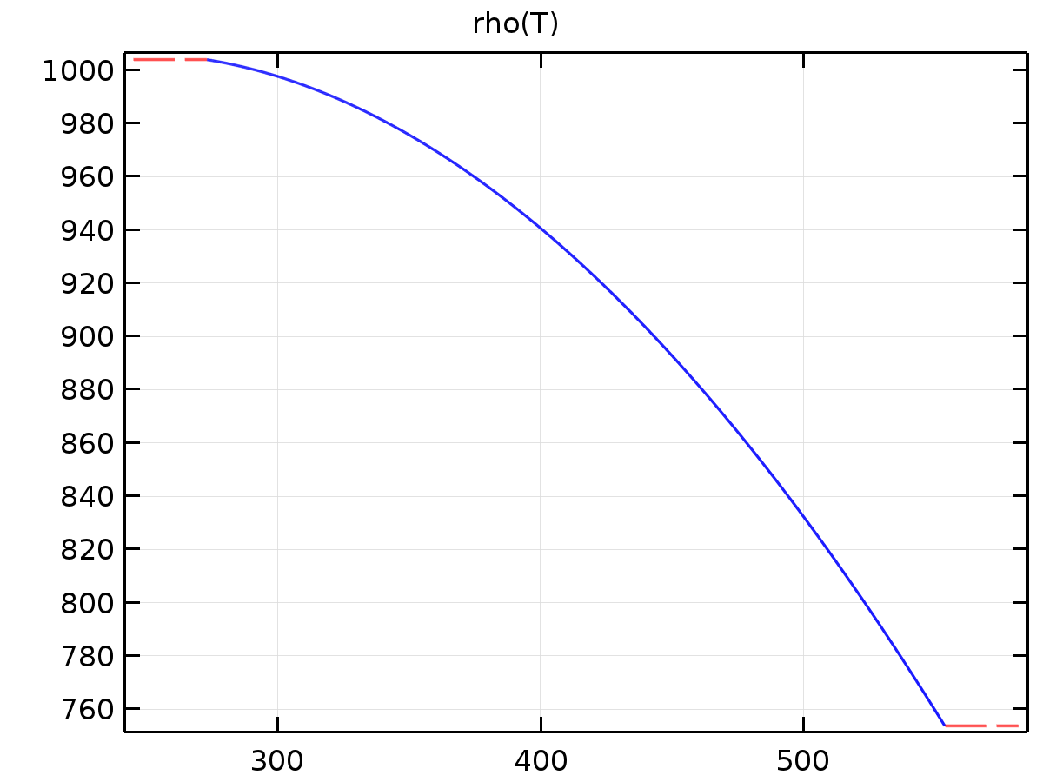
rho
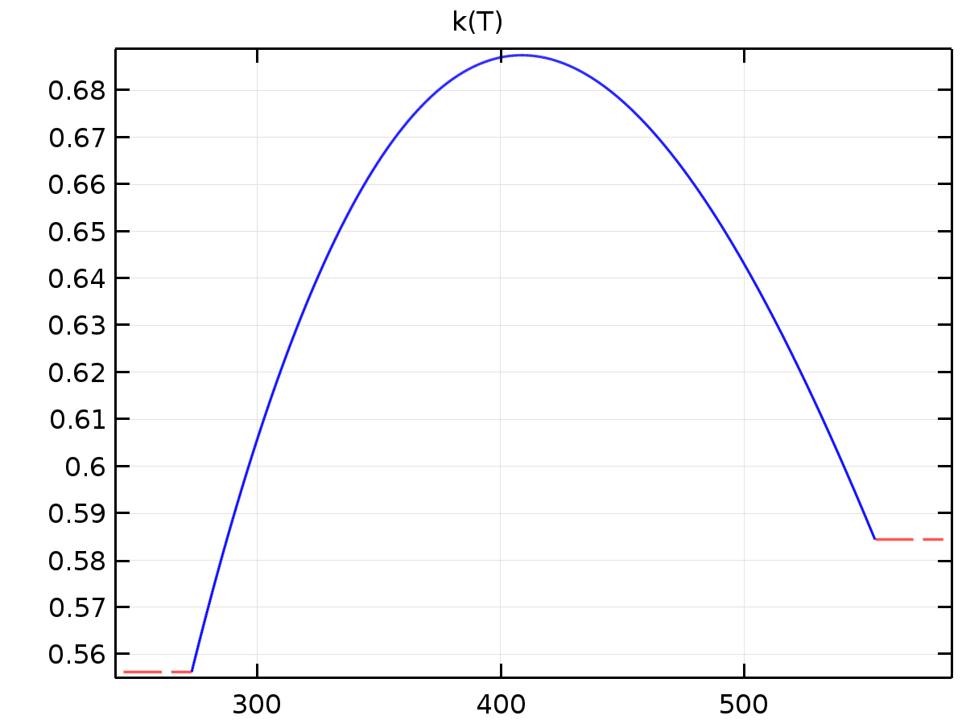
k
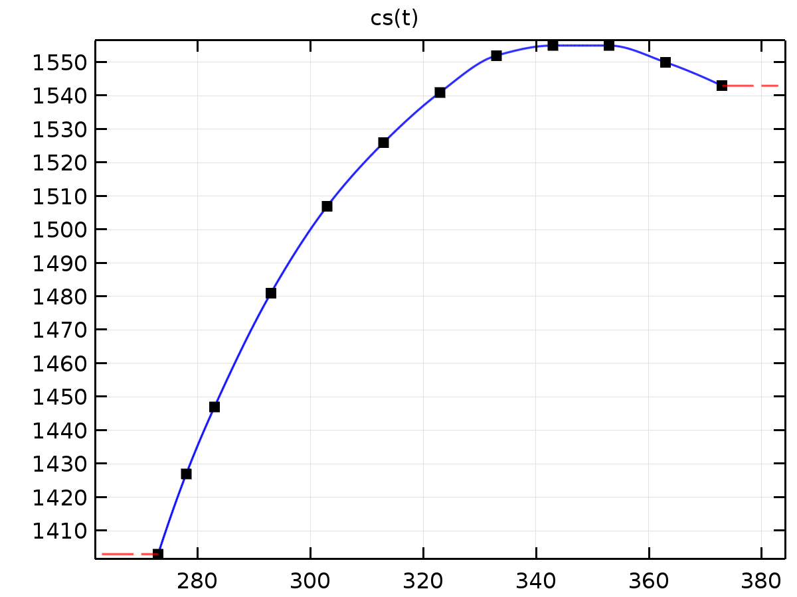
cs
  - Electroanalysis
Used products
COMSOL Multiphysics
Electrochemistry Module

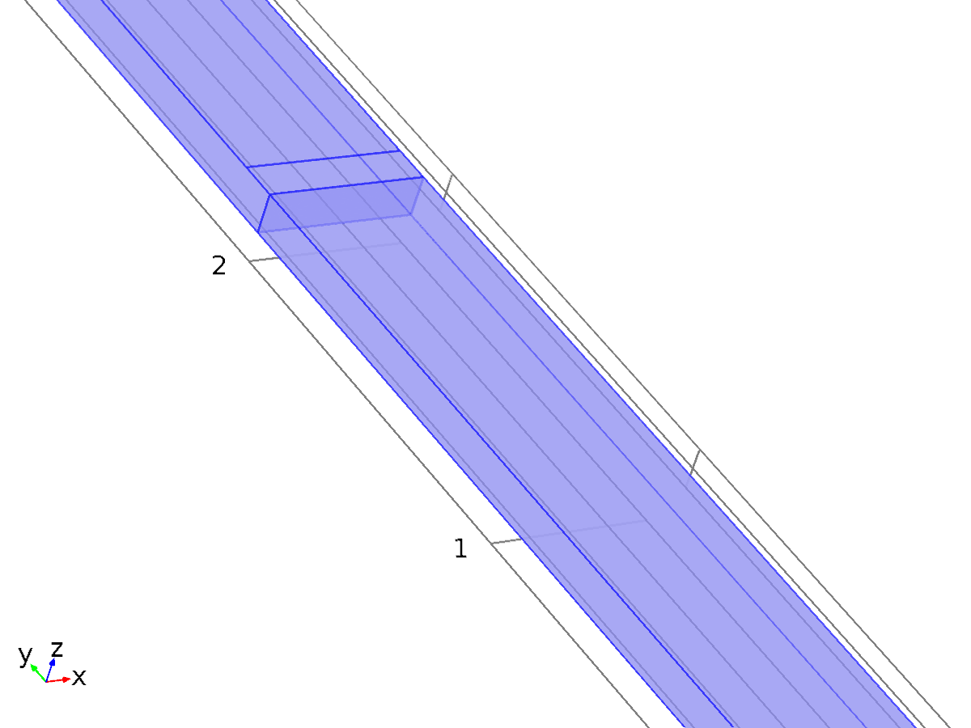
Electroanalysis
Selection
Geometric entity level | Domain
Selection | Domains 1–2

Equations
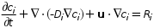
Settings
Description | Value
Concentration | Linear
Compute boundary fluxes | On
Apply smoothing to boundary fluxes | On
Value type when using splitting of complex variables | Real
Convection | On
Migration in electric field | Off
Streamline diffusion | On
Crosswind diffusion | On
Equation residual | Approximate residual
Crosswind diffusion type | Do Carmo and Galeão
Isotropic diffusion | Off
Convective term | Non - conservative form

Variables
Name | Expression | Unit | Description | Selection
domflux.cRexx | elan.dflux_cRexx | mol/(m^2*s) | Domain flux, x component | Domains 1–2
domflux.cRexy | elan.dflux_cRexy | mol/(m^2*s) | Domain flux, y component | Domains 1–2
domflux.cRexz | elan.dflux_cRexz | mol/(m^2*s) | Domain flux, z component | Domains 1–2
domflux.cOxx | elan.dflux_cOxx | mol/(m^2*s) | Domain flux, x component | Domains 1–2
domflux.cOxy | elan.dflux_cOxy | mol/(m^2*s) | Domain flux, y component | Domains 1–2
domflux.cOxz | elan.dflux_cOxz | mol/(m^2*s) | Domain flux, z component | Domains 1–2
elan.mulstopcond | 1 | 1 | Multiplicative stop condition | Global
elan.stopcond | elan.mulstopcond | 1 | Solver stop condition | Global
elan.nx | nx | 1 | Normal vector, x component | Boundary 6
elan.ny | ny | 1 | Normal vector, y component | Boundary 6
elan.nz | nz | 1 | Normal vector, z component | Boundary 6
elan.nx | dnx | 1 | Normal vector, x component | Boundaries 1–5, 7–12
elan.ny | dny | 1 | Normal vector, y component | Boundaries 1–5, 7–12
elan.nz | dnz | 1 | Normal vector, z component | Boundaries 1–5, 7–12
elan.nxmesh | root.nxmesh | 1 | Normal vector (mesh), x component | Boundary 6
elan.nymesh | root.nymesh | 1 | Normal vector (mesh), y component | Boundary 6
elan.nzmesh | root.nzmesh | 1 | Normal vector (mesh), z component | Boundary 6
elan.nxmesh | root.dnxmesh | 1 | Normal vector (mesh), x component | Boundaries 1–5, 7–12
elan.nymesh | root.dnymesh | 1 | Normal vector (mesh), y component | Boundaries 1–5, 7–12
elan.nzmesh | root.dnzmesh | 1 | Normal vector (mesh), z component | Boundaries 1–5, 7–12
elan.nxc | root.nxc/sqrt(root.nxc^2+root.nyc^2+root.nzc^2+eps) | 1 | Normal vector, x component | Boundaries 1–12
elan.nyc | root.nyc/sqrt(root.nxc^2+root.nyc^2+root.nzc^2+eps) | 1 | Normal vector, y component | Boundaries 1–12
elan.nzc | root.nzc/sqrt(root.nxc^2+root.nyc^2+root.nzc^2+eps) | 1 | Normal vector, z component | Boundaries 1–12
elan.ndflux_cRex | elan.bndFlux_cRex | mol/(m^2*s) | Normal diffusive flux | Boundaries 1–12
elan.ndflux_cOx | elan.bndFlux_cOx | mol/(m^2*s) | Normal diffusive flux | Boundaries 1–12
elan.ncflux_cRex | elan.cflux_cRexx*elan.nxc+elan.cflux_cRexy*elan.nyc+elan.cflux_cRexz*elan.nzc | mol/(m^2*s) | Normal convective flux | Boundaries 1–12
elan.ncflux_cOx | elan.cflux_cOxx*elan.nxc+elan.cflux_cOxy*elan.nyc+elan.cflux_cOxz*elan.nzc | mol/(m^2*s) | Normal convective flux | Boundaries 1–12
elan.ntflux_cRex | elan.bndFlux_cRex+elan.cflux_cRexx*elan.nxc+elan.cflux_cRexy*elan.nyc+elan.cflux_cRexz*elan.nzc | mol/(m^2*s) | Normal total flux | Boundaries 1–12
elan.ntflux_cOx | elan.bndFlux_cOx+elan.cflux_cOxx*elan.nxc+elan.cflux_cOxy*elan.nyc+elan.cflux_cOxz*elan.nzc | mol/(m^2*s) | Normal total flux | Boundaries 1–12
elan.bndFlux_cRex | -dflux_spatial(cRex) | mol/(m^2*s) | Boundary flux | Boundaries 1–5, 7–12
elan.bndFlux_cRex | 0.5*(uflux_spatial(cRex)-dflux_spatial(cRex)) | mol/(m^2*s) | Boundary flux | Boundary 6
elan.bndFlux_cOx | -dflux_spatial(cOx) | mol/(m^2*s) | Boundary flux | Boundaries 1–5, 7–12
elan.bndFlux_cOx | 0.5*(uflux_spatial(cOx)-dflux_spatial(cOx)) | mol/(m^2*s) | Boundary flux | Boundary 6
elan.R_cRex | 0 | mol/(m^3*s) | Total rate expression | Domains 1–2
elan.R_cOx | 0 | mol/(m^3*s) | Total rate expression | Domains 1–2
elan.nil | 0 | A/m^2 | Inward electrolyte current density | Domains 1–2

    - Transport Properties 1
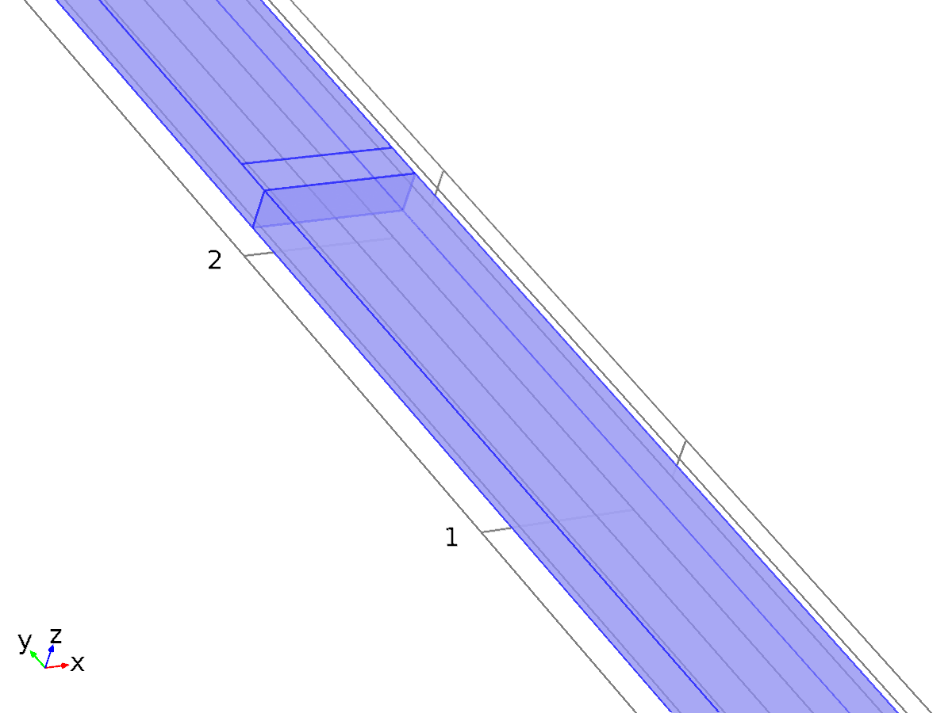
Transport Properties 1
Selection
Geometric entity level | Domain
Selection | Domains 1–2

Equations
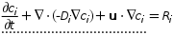
Settings
Description | Value
Velocity field | Velocity field (spf)
Material | None
Diffusion coefficient | User defined
Diffusion coefficient | {{D, 0, 0}, {0, D, 0}, {0, 0, D}}
Diffusion coefficient | User defined
Diffusion coefficient | {{D2, 0, 0}, {0, D2, 0}, {0, 0, D2}}

Variables
Name | Expression | Unit | Description | Selection
elan.cbf_cRex | 0 | mol/(m^2*s) | Convective boundary flux | Boundaries 1–12
elan.cbf_cOx | 0 | mol/(m^2*s) | Convective boundary flux | Boundaries 1–12
elan.D_cRexxx | D | m^2/s | Diffusion coefficient, xx component | Domains 1–2
elan.D_cRexyx | 0 | m^2/s | Diffusion coefficient, yx component | Domains 1–2
elan.D_cRexzx | 0 | m^2/s | Diffusion coefficient, zx component | Domains 1–2
elan.D_cRexxy | 0 | m^2/s | Diffusion coefficient, xy component | Domains 1–2
elan.D_cRexyy | D | m^2/s | Diffusion coefficient, yy component | Domains 1–2
elan.D_cRexzy | 0 | m^2/s | Diffusion coefficient, zy component | Domains 1–2
elan.D_cRexxz | 0 | m^2/s | Diffusion coefficient, xz component | Domains 1–2
elan.D_cRexyz | 0 | m^2/s | Diffusion coefficient, yz component | Domains 1–2
elan.D_cRexzz | D | m^2/s | Diffusion coefficient, zz component | Domains 1–2
elan.D_cOxxx | D2 | m^2/s | Diffusion coefficient, xx component | Domains 1–2
elan.D_cOxyx | 0 | m^2/s | Diffusion coefficient, yx component | Domains 1–2
elan.D_cOxzx | 0 | m^2/s | Diffusion coefficient, zx component | Domains 1–2
elan.D_cOxxy | 0 | m^2/s | Diffusion coefficient, xy component | Domains 1–2
elan.D_cOxyy | D2 | m^2/s | Diffusion coefficient, yy component | Domains 1–2
elan.D_cOxzy | 0 | m^2/s | Diffusion coefficient, zy component | Domains 1–2
elan.D_cOxxz | 0 | m^2/s | Diffusion coefficient, xz component | Domains 1–2
elan.D_cOxyz | 0 | m^2/s | Diffusion coefficient, yz component | Domains 1–2
elan.D_cOxzz | D2 | m^2/s | Diffusion coefficient, zz component | Domains 1–2
elan.Dav_cRex | (elan.D_cRexxx+elan.D_cRexyy+elan.D_cRexzz)/3 | m^2/s | Average diffusion coefficient | Domains 1–2
elan.Dav_cOx | (elan.D_cOxxx+elan.D_cOxyy+elan.D_cOxzz)/3 | m^2/s | Average diffusion coefficient | Domains 1–2
elan.tflux_cRexx | elan.dflux_cRexx+elan.cflux_cRexx | mol/(m^2*s) | Total flux, x component | Domains 1–2
elan.tflux_cRexy | elan.dflux_cRexy+elan.cflux_cRexy | mol/(m^2*s) | Total flux, y component | Domains 1–2
elan.tflux_cRexz | elan.dflux_cRexz+elan.cflux_cRexz | mol/(m^2*s) | Total flux, z component | Domains 1–2
elan.tflux_cOxx | elan.dflux_cOxx+elan.cflux_cOxx | mol/(m^2*s) | Total flux, x component | Domains 1–2
elan.tflux_cOxy | elan.dflux_cOxy+elan.cflux_cOxy | mol/(m^2*s) | Total flux, y component | Domains 1–2
elan.tflux_cOxz | elan.dflux_cOxz+elan.cflux_cOxz | mol/(m^2*s) | Total flux, z component | Domains 1–2
elan.dfluxMag_cRex | sqrt(elan.dflux_cRexx^2+elan.dflux_cRexy^2+elan.dflux_cRexz^2) | mol/(m^2*s) | Diffusive flux magnitude | Domains 1–2
elan.dfluxMag_cOx | sqrt(elan.dflux_cOxx^2+elan.dflux_cOxy^2+elan.dflux_cOxz^2) | mol/(m^2*s) | Diffusive flux magnitude | Domains 1–2
elan.tfluxMag_cRex | sqrt(elan.tflux_cRexx^2+elan.tflux_cRexy^2+elan.tflux_cRexz^2) | mol/(m^2*s) | Total flux magnitude | Domains 1–2
elan.tfluxMag_cOx | sqrt(elan.tflux_cOxx^2+elan.tflux_cOxy^2+elan.tflux_cOxz^2) | mol/(m^2*s) | Total flux magnitude | Domains 1–2
elan.dflux_cRexx | -elan.D_cRexxx*cRexx-elan.D_cRexxy*cRexy-elan.D_cRexxz*cRexz | mol/(m^2*s) | Diffusive flux, x component | Domains 1–2
elan.dflux_cRexy | -elan.D_cRexyx*cRexx-elan.D_cRexyy*cRexy-elan.D_cRexyz*cRexz | mol/(m^2*s) | Diffusive flux, y component | Domains 1–2
elan.dflux_cRexz | -elan.D_cRexzx*cRexx-elan.D_cRexzy*cRexy-elan.D_cRexzz*cRexz | mol/(m^2*s) | Diffusive flux, z component | Domains 1–2
elan.dflux_cOxx | -elan.D_cOxxx*cOxx-elan.D_cOxxy*cOxy-elan.D_cOxxz*cOxz | mol/(m^2*s) | Diffusive flux, x component | Domains 1–2
elan.dflux_cOxy | -elan.D_cOxyx*cOxx-elan.D_cOxyy*cOxy-elan.D_cOxyz*cOxz | mol/(m^2*s) | Diffusive flux, y component | Domains 1–2
elan.dflux_cOxz | -elan.D_cOxzx*cOxx-elan.D_cOxzy*cOxy-elan.D_cOxzz*cOxz | mol/(m^2*s) | Diffusive flux, z component | Domains 1–2
elan.grad_cRexx | cRexx | mol/m^4 | Concentration gradient, x component | Domains 1–2
elan.grad_cRexy | cRexy | mol/m^4 | Concentration gradient, y component | Domains 1–2
elan.grad_cRexz | cRexz | mol/m^4 | Concentration gradient, z component | Domains 1–2
elan.grad_cOxx | cOxx | mol/m^4 | Concentration gradient, x component | Domains 1–2
elan.grad_cOxy | cOxy | mol/m^4 | Concentration gradient, y component | Domains 1–2
elan.grad_cOxz | cOxz | mol/m^4 | Concentration gradient, z component | Domains 1–2
elan.u | model.input.u1 | m/s | Velocity field, x component | Domains 1–2
elan.v | model.input.u2 | m/s | Velocity field, y component | Domains 1–2
elan.w | model.input.u3 | m/s | Velocity field, z component | Domains 1–2
elan.cflux_cRexx | cRex*model.input.u1 | mol/(m^2*s) | Convective flux, x component | Domains 1–2
elan.cflux_cRexy | cRex*model.input.u2 | mol/(m^2*s) | Convective flux, y component | Domains 1–2
elan.cflux_cRexz | cRex*model.input.u3 | mol/(m^2*s) | Convective flux, z component | Domains 1–2
elan.cflux_cOxx | cOx*model.input.u1 | mol/(m^2*s) | Convective flux, x component | Domains 1–2
elan.cflux_cOxy | cOx*model.input.u2 | mol/(m^2*s) | Convective flux, y component | Domains 1–2
elan.cflux_cOxz | cOx*model.input.u3 | mol/(m^2*s) | Convective flux, z component | Domains 1–2
elan.cfluxMag_cRex | sqrt(elan.cflux_cRexx^2+elan.cflux_cRexy^2+elan.cflux_cRexz^2) | mol/(m^2*s) | Convective flux magnitude | Domains 1–2
elan.cfluxMag_cOx | sqrt(elan.cflux_cOxx^2+elan.cflux_cOxy^2+elan.cflux_cOxz^2) | mol/(m^2*s) | Convective flux magnitude | Domains 1–2
elan.phil | 0 | V | Electrolyte potential | Domains 1–2
elan.Res_cRex | elan.u*cRexx+elan.v*cRexy+elan.w*cRexz-elan.R_cRex | mol/(m^3*s) | Equation residual | Domains 1–2
elan.Res_cOx | elan.u*cOxx+elan.v*cOxy+elan.w*cOxz-elan.R_cOx | mol/(m^3*s) | Equation residual | Domains 1–2

Shape functions
Name | Shape function | Unit | Description | Shape frame | Selection
cRex | Lagrange (Linear) | mol/m^3 | Concentration | Material | Domains 1–2
cOx | Lagrange (Linear) | mol/m^3 | Concentration | Material | Domains 1–2

Weak expressions
Weak expression | Integration frame | Selection
-cRext*test(cRex)+elan.dflux_cRexx*test(cRexx)+elan.dflux_cRexy*test(cRexy)+elan.dflux_cRexz*test(cRexz) | Material | Domains 1–2
-cOxt*test(cOx)+elan.dflux_cOxx*test(cOxx)+elan.dflux_cOxy*test(cOxy)+elan.dflux_cOxz*test(cOxz) | Material | Domains 1–2
-(elan.u*cRexx+elan.v*cRexy+elan.w*cRexz)*test(cRex)*(isScalingSystemDomain==0) | Material | Domains 1–2
-(elan.u*cOxx+elan.v*cOxy+elan.w*cOxz)*test(cOx)*(isScalingSystemDomain==0) | Material | Domains 1–2
elan.cbf_cRex*test(cRex) | Material | Boundaries 1–12
elan.cbf_cOx*test(cOx) | Material | Boundaries 1–12
elan.streamline*(isScalingSystemDomain==0) | Material | Domains 1–2
elan.crosswind*(isScalingSystemDomain==0) | Material | Domains 1–2

    - No Flux 1
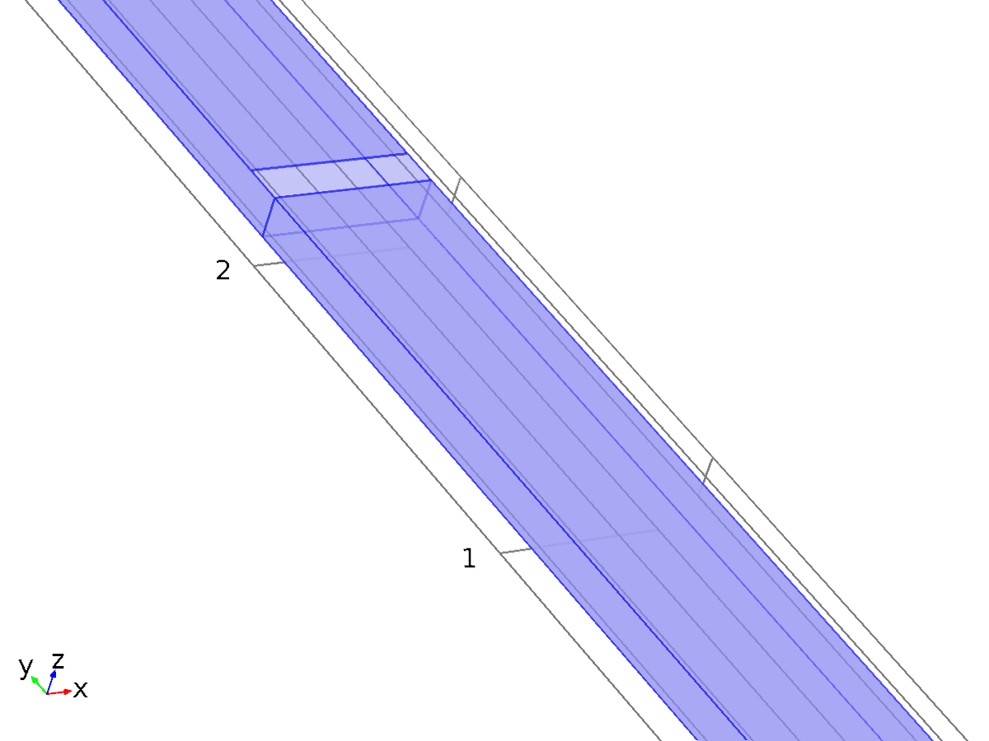
No Flux 1
Selection
Geometric entity level | Boundary
Selection | Boundaries 1, 3–5, 7, 9, 11–12

Equations

Variables
Name | Expression | Unit | Description | Selection
elan.cbf_cRex | cRex*(elan.u*elan.nxmesh+elan.v*elan.nymesh+elan.w*elan.nzmesh) | mol/(m^2*s) | Convective boundary flux | Boundaries 1, 3–5, 7, 9, 11–12
elan.cbf_cOx | cOx*(elan.u*elan.nxmesh+elan.v*elan.nymesh+elan.w*elan.nzmesh) | mol/(m^2*s) | Convective boundary flux | Boundaries 1, 3–5, 7, 9, 11–12

    - Initial Values 1
Initial Values 1
Selection
Geometric entity level | Domain
Selection | Domains 1–2

Settings
Description | Value
Concentration | {C_in, 0}

    - Inflow 1
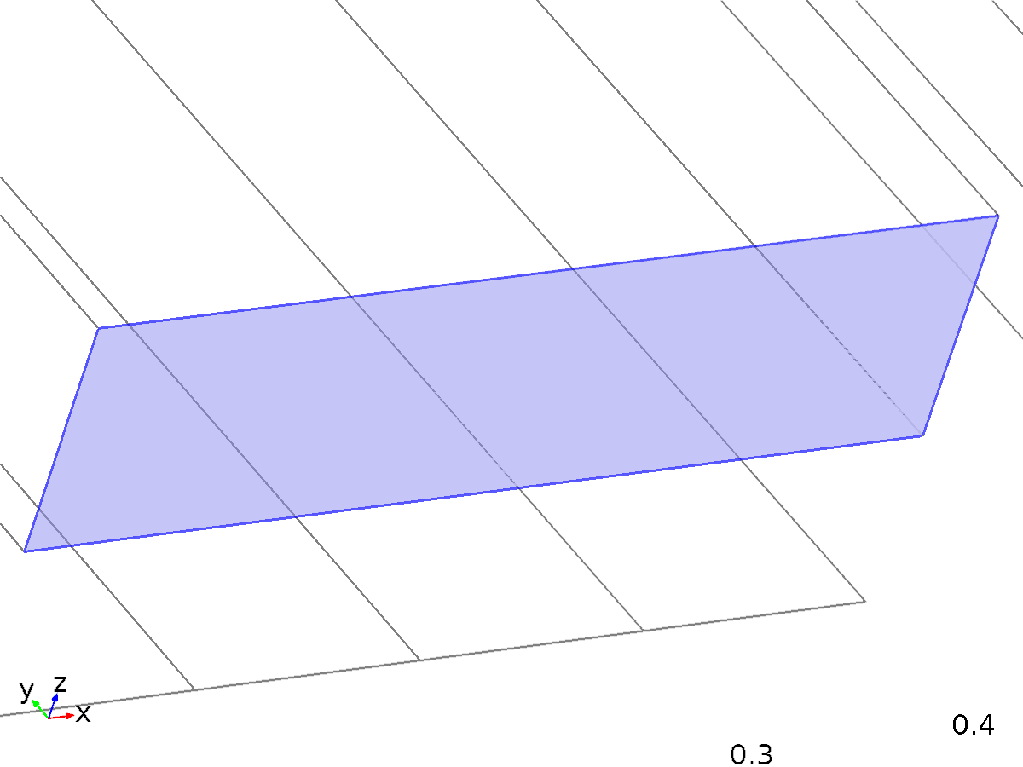
Inflow 1
Selection
Geometric entity level | Boundary
Selection | Boundary 2

Equations
Settings
Description | Value
Concentration | {C_in, 0}
Boundary condition type | Concentration constraint
Apply reaction terms on | Individual dependent variables
Use weak constraints | Off
Constraint method | Elemental

Variables
Name | Expression | Unit | Description | Selection
elan.c0_cRex | C_in | mol/m^3 | Concentration | Boundary 2
elan.c0_cOx | 0 | mol/m^3 | Concentration | Boundary 2
elan.in1.c0_avg_cRex | elan.in1.int(cRex*(elan.u*elan.nx+elan.v*elan.ny+elan.w*elan.nz))/elan.in1.int(elan.u*elan.nx+elan.v*elan.ny+elan.w*elan.nz) | mol/m^3 | Concentration | Global
elan.in1.c0_avg_cOx | elan.in1.int(cOx*(elan.u*elan.nx+elan.v*elan.ny+elan.w*elan.nz))/elan.in1.int(elan.u*elan.nx+elan.v*elan.ny+elan.w*elan.nz) | mol/m^3 | Concentration | Global

Shape functions
Constraint | Constraint force | Shape function | Selection
-cRex+elan.c0_cRex | -test(cRex) | Lagrange (Linear) | Boundary 2
-cOx+elan.c0_cOx | -test(cOx) | Lagrange (Linear) | Boundary 2

    - Electrode Surface 1
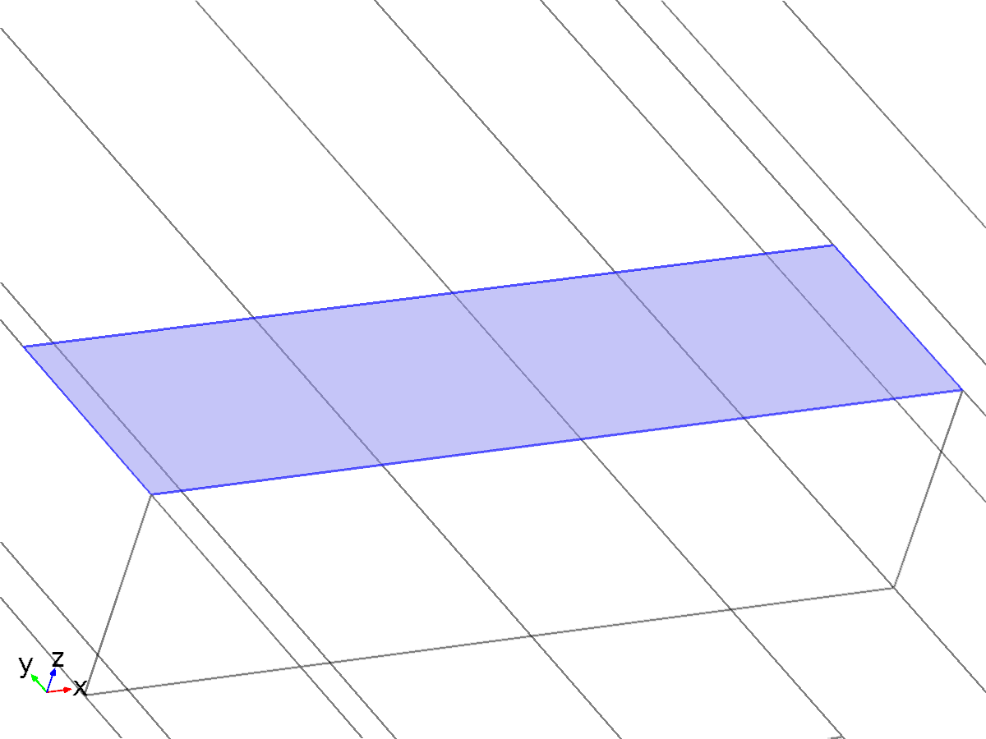
Electrode Surface 1
Selection
Geometric entity level | Boundary
Selection | Boundary 8

Equations
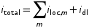
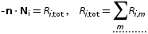
Settings
Description | Value
Film resistance | No film resistance
Boundary condition | Cyclic voltammetry
Linear sweep rate | 20[mV/s]
Start potential | On
Start potential | 0.5
Number of cycles | 1
Vertex potential 1 | 0.5[V]
Vertex potential 2 | -0.5[V]
End potential | On
End potential | 0
Perturbation amplitude | 0

Variables
Name | Expression | Unit | Description | Selection
elan.mulstopcond | t>(abs(-0.5+0.5[V])+elan.ncycle_els1*abs(2*(0.5[V]-(-0.5)[V]))+abs(0.5[V]))/20[mV/s] | 1 | Multiplicative stop condition | Global
elan.nil | elan.itot | A/m^2 | Inward electrolyte current density | Boundary 8
elan.ncycle_els1 | 1 | 1 | Number of cycles | Global
elan.Itot_els1 | elan.els1.int(elan.itot*elan.dvolfactor) | A | Total current | Global
elan.phis_els1 | elan.els1.int(elan.phisext*elan.dvolfactor)/elan.Area_els1 | V | Electric potential | Global
elan.Ect | elan.phisext-elan.phil | V | Electrode potential | Boundary 8
elan.Area_els1 | elan.els1.int(elan.dvolfactor) | m^2 | Area | Global
elan.dvolfactor | 1 | 1 | Differential volume factor | Boundary 8
elan.itotavg_els1 | elan.els1.int(elan.itot*elan.dvolfactor)/elan.Area_els1 | A/m^2 | Average total interface current density | Global
elan.Temp | model.input.minput_temperature | K | Temperature | Boundary 8
elan.itot | 0 | A/m^2 | Total interface current density | Boundary 8
elan.cycle_els1 | max(round(0.5+(min(0,(abs(-0.5+0.5[V])+(-1+elan.ncycle_els1)*abs(2*(0.5[V]-(-0.5)[V])))/20[mV/s])-abs(-0.5+0.5[V])/20[mV/s])*20[mV/s]/abs(2*(0.5[V]-(-0.5)[V]))),1) | 1 | Cycle number | Global
elan.phisext | elan.cv_els1(0) | V | External electric potential | Boundary 8

Electrode Reaction 1
Electrode Reaction 1
Selection
Geometric entity level | Boundary
Selection | Boundary 8

Equations
Settings
Description | Value
Equilibrium potential | User defined
Equilibrium potential | 0
Temperature derivative of equilibrium potential | User defined
Temperature derivative of equilibrium potential | 0
Kinetics expression type | Electroanalytical Butler - Volmer
Cathodic transfer coefficient | 0.5
Heterogenous rate constant | 0.01[m/s]
Number of participating electrons | 1
Stoichiometric coefficient | {-1, 1}

Variables
Name | Expression | Unit | Description | Selection
elan.itot | elan.iloc_er1 | A/m^2 | Total interface current density | Boundary 8
elan.Eeq_er1 | 0 | V | Equilibrium potential | Boundary 8
elan.dEeqdT_er1 | 0 | V/K | Temperature derivative of equilibrium potential | Boundary 8
elan.iloc_er1 | F_const*elan.k0_er1*(elan.cred*exp((1-elan.alphac_er1)*F_const*elan.eta_er1/(R_const*model.input.minput_temperature))-elan.cox*exp(-elan.alphac_er1*F_const*elan.eta_er1/(R_const*model.input.minput_temperature))) | A/m^2 | Local current density | Boundary 8
elan.alphac_er1 | 0.5 | 1 | Cathodic transfer coefficient | Boundary 8
elan.k0_er1 | 0.01[m/s] | m/s | Heterogenous rate constant | Boundary 8
elan.els1.er1.iloc | elan.iloc_er1 | A/m^2 | Local current density | Boundary 8
elan.els1.er1.Vi0_cRex | -1 | 1 | Stoichiometric coefficient | Boundary 8
elan.els1.er1.Vi0_cOx | 1 | 1 | Stoichiometric coefficient | Boundary 8
elan.cred | cOx | mol/m^3 | Reduced species concentration | Boundary 8
elan.cox | cRex | mol/m^3 | Oxidized species concentration | Boundary 8
elan.els1.er1.N0_cRex | elan.iloc_er1/F_const | mol/(m^2*s) | Inward flux | Boundary 8
elan.els1.er1.N0_cOx | -elan.iloc_er1/F_const | mol/(m^2*s) | Inward flux | Boundary 8
elan.Qirrev_er1 | elan.iloc_er1*elan.eta_er1 | W/m^2 | Irreversible heat flux | Boundary 8
elan.Qrev_er1 | elan.iloc_er1*model.input.minput_temperature*elan.dEeqdT_er1 | W/m^2 | Reversible heat flux | Boundary 8
elan.Qbfc | elan.Qrev_er1+elan.Qirrev_er1 | W/m^2 | Electrochemical reaction boundary heat source | Boundary 8
elan.eta_er1 | elan.Ect-elan.Eeq_er1 | V | Overpotential | Boundary 8

Weak expressions
Weak expression | Integration frame | Selection
elan.els1.er1.N0_cRex*test(cRex) | Material | Boundary 8
elan.els1.er1.N0_cOx*test(cOx) | Material | Boundary 8

    - Outflow 1
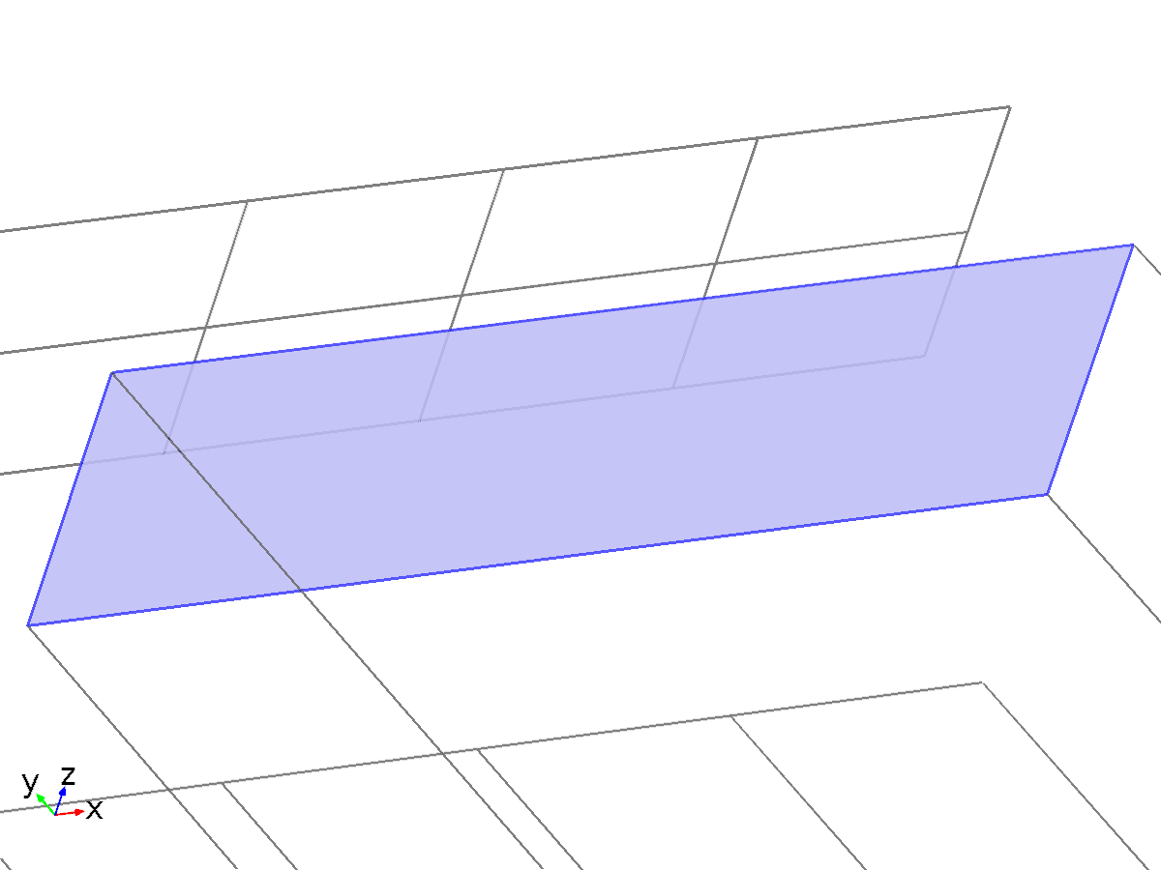
Outflow 1
Selection
Geometric entity level | Boundary
Selection | Boundary 10

Equations

Variables
Name | Expression | Unit | Description | Selection
elan.out1.c0_avg_cRex | elan.out1.int(cRex*(elan.u*elan.nx+elan.v*elan.ny+elan.w*elan.nz))/elan.out1.int(elan.u*elan.nx+elan.v*elan.ny+elan.w*elan.nz) | mol/m^3 | Concentration | Global
elan.out1.c0_avg_cOx | elan.out1.int(cOx*(elan.u*elan.nx+elan.v*elan.ny+elan.w*elan.nz))/elan.out1.int(elan.u*elan.nx+elan.v*elan.ny+elan.w*elan.nz) | mol/m^3 | Concentration | Global

Weak expressions
Weak expression | Integration frame | Selection
0 | Material | Boundary 10
0 | Material | Boundary 10

  - Laminar Flow
Used products
COMSOL Multiphysics

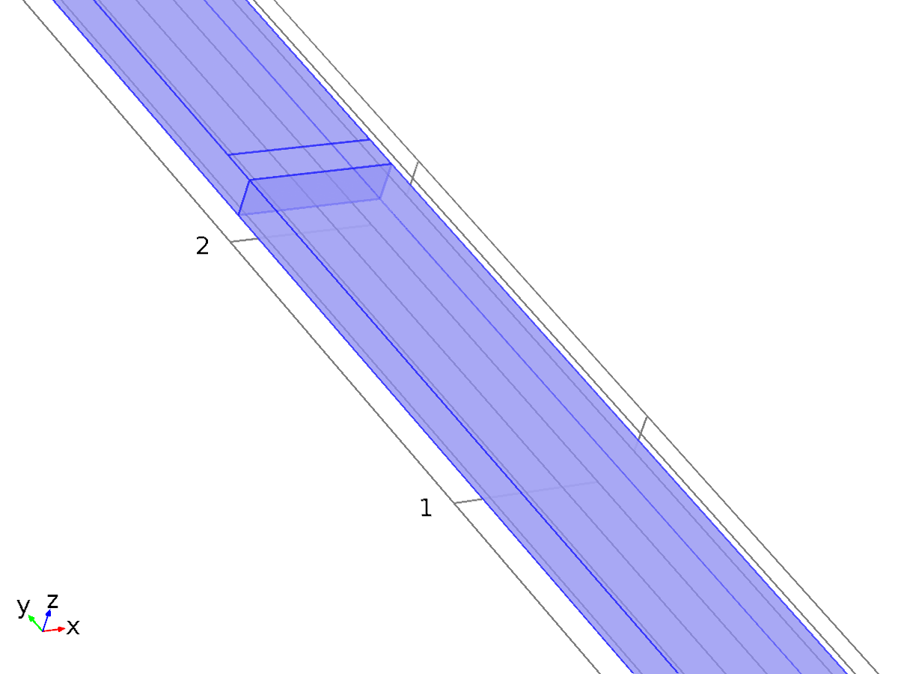
Laminar Flow
Selection
Geometric entity level | Domain
Selection | Domains 1–2

Equations
Settings
Description | Value
Discretization of fluids | P1 + P1
Value type when using splitting of complex variables | {Real, Real, Real, Real, Real, Real, Real, Real, Real, Real, Real}
Neglect inertial term (Stokes flow) | Off
Compressibility | Incompressible flow
Turbulence model type | None
Reference pressure level | 1[atm]
Enable porous media domains | Off
Streamline diffusion | On
Crosswind diffusion | On
Isotropic diffusion | Off
Use pseudo time stepping for stationary equation form | Off

Variables
Name | Expression | Unit | Description | Selection
spf.dz | 1 | m | Thickness | Domains 1–2
spf.pref | 1[atm] | Pa | Reference pressure level | Domains 1–2
spf.pA | p+spf.pref | Pa | Absolute pressure | Domains 1–2
spf.nx | nx | 1 | Normal vector, x component | Boundary 6
spf.ny | ny | 1 | Normal vector, y component | Boundary 6
spf.nz | nz | 1 | Normal vector, z component | Boundary 6
spf.nx | dnx | 1 | Normal vector, x component | Boundaries 1–5, 7–12
spf.ny | dny | 1 | Normal vector, y component | Boundaries 1–5, 7–12
spf.nz | dnz | 1 | Normal vector, z component | Boundaries 1–5, 7–12
spf.nxmesh | root.nxmesh | 1 | Normal vector, x component | Boundary 6
spf.nymesh | root.nymesh | 1 | Normal vector, y component | Boundary 6
spf.nzmesh | root.nzmesh | 1 | Normal vector, z component | Boundary 6
spf.nxmesh | root.dnxmesh | 1 | Normal vector, x component | Boundaries 1–5, 7–12
spf.nymesh | root.dnymesh | 1 | Normal vector, y component | Boundaries 1–5, 7–12
spf.nzmesh | root.dnzmesh | 1 | Normal vector, z component | Boundaries 1–5, 7–12

    - Fluid Properties 1
Fluid Properties 1
Selection
Geometric entity level | Domain
Selection | Domains 1–2

Equations
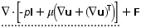
Settings
Description | Value
Density | From material
Dynamic viscosity | From material

Properties from material
Property | Material | Property group
Density | Water | Basic
Dynamic viscosity | Water | Basic

Variables
Name | Expression | Unit | Description | Selection
spf.mu | material.mu | Pa*s | Dynamic viscosity | Domains 1–2
spf.epsilon_p | 1 | 1 | Porosity | Domains 1–2
spf.rho | subst(material.rho,spf.pA,spf.pref) | kg/m^3 | Density | Domains 1–2
spf.sr | sqrt(0.5*(4*ux^2+2*(uy+vx)^2+2*(uz+wx)^2+4*vy^2+2*(vz+wy)^2+4*wz^2)+eps) | 1/s | Shear rate | Domains 1–2
spf.divu | ux+vy+wz | 1/s | Divergence of velocity field | Domains 1–2
spf.Fx | 0 | N/m^3 | Volume force, x component | Domains 1–2
spf.Fy | 0 | N/m^3 | Volume force, y component | Domains 1–2
spf.Fz | 0 | N/m^3 | Volume force, z component | Domains 1–2
spf.U | sqrt(u^2+v^2+w^2) | m/s | Velocity magnitude | Domains 1–2
spf.vorticityx | wy-vz | 1/s | Vorticity field, x component | Domains 1–2
spf.vorticityy | -wx+uz | 1/s | Vorticity field, y component | Domains 1–2
spf.vorticityz | vx-uy | 1/s | Vorticity field, z component | Domains 1–2
spf.vort_magn | sqrt(spf.vorticityx^2+spf.vorticityy^2+spf.vorticityz^2) | 1/s | Vorticity magnitude | Domains 1–2
spf.cellRe | 0.25*spf.rho*sqrt(emetric(u,v,w)/emetric2)/spf.mu | 1 | Cell Reynolds number | Domains 1–2
spf.nu | spf.mu/spf.rho | m^2/s | Kinematic viscosity | Domains 1–2
spf.betaT | 0 | 1/Pa | Isothermal compressibility coefficient | Domains 1–2
spf.mu_eff | spf.mu+spf.muT | Pa*s | Dynamic viscosity | Domains 1–2
spf.muT | 0 | Pa*s | Turbulent dynamic viscosity | Domains 1–2
spf.T_stressx | spf.K_stressx-p*spf.nxmesh | N/m^2 | Total stress, x component | Boundaries 1–12
spf.T_stressy | spf.K_stressy-p*spf.nymesh | N/m^2 | Total stress, y component | Boundaries 1–12
spf.T_stressz | spf.K_stressz-p*spf.nzmesh | N/m^2 | Total stress, z component | Boundaries 1–12
spf.K_stressx | spf.mu_eff*(2*ux*spf.nxmesh+(uy+vx)*spf.nymesh+(uz+wx)*spf.nzmesh) | N/m^2 | Viscous stress, x component | Boundaries 1–12
spf.K_stressy | spf.mu_eff*((vx+uy)*spf.nxmesh+2*vy*spf.nymesh+(vz+wy)*spf.nzmesh) | N/m^2 | Viscous stress, y component | Boundaries 1–12
spf.K_stressz | spf.mu_eff*((wx+uz)*spf.nxmesh+(wy+vz)*spf.nymesh+2*wz*spf.nzmesh) | N/m^2 | Viscous stress, z component | Boundaries 1–12
spf.K_stress_tensorxx | 2*spf.mu_eff*ux | N/m^2 | Viscous stress tensor, xx component | Domains 1–2
spf.K_stress_tensoryx | spf.mu_eff*(vx+uy) | N/m^2 | Viscous stress tensor, yx component | Domains 1–2
spf.K_stress_tensorzx | spf.mu_eff*(wx+uz) | N/m^2 | Viscous stress tensor, zx component | Domains 1–2
spf.K_stress_tensorxy | spf.mu_eff*(uy+vx) | N/m^2 | Viscous stress tensor, xy component | Domains 1–2
spf.K_stress_tensoryy | 2*spf.mu_eff*vy | N/m^2 | Viscous stress tensor, yy component | Domains 1–2
spf.K_stress_tensorzy | spf.mu_eff*(wy+vz) | N/m^2 | Viscous stress tensor, zy component | Domains 1–2
spf.K_stress_tensorxz | spf.mu_eff*(uz+wx) | N/m^2 | Viscous stress tensor, xz component | Domains 1–2
spf.K_stress_tensoryz | spf.mu_eff*(vz+wy) | N/m^2 | Viscous stress tensor, yz component | Domains 1–2
spf.K_stress_tensorzz | 2*spf.mu_eff*wz | N/m^2 | Viscous stress tensor, zz component | Domains 1–2
spf.K_stress_tensor_testxx | 2*spf.mu_eff*test(ux) | N/m^2 | Viscous stress tensor test, xx component | Domains 1–2
spf.K_stress_tensor_testyx | spf.mu_eff*(test(vx)+test(uy)) | N/m^2 | Viscous stress tensor test, yx component | Domains 1–2
spf.K_stress_tensor_testzx | spf.mu_eff*(test(wx)+test(uz)) | N/m^2 | Viscous stress tensor test, zx component | Domains 1–2
spf.K_stress_tensor_testxy | spf.mu_eff*(test(uy)+test(vx)) | N/m^2 | Viscous stress tensor test, xy component | Domains 1–2
spf.K_stress_tensor_testyy | 2*spf.mu_eff*test(vy) | N/m^2 | Viscous stress tensor test, yy component | Domains 1–2
spf.K_stress_tensor_testzy | spf.mu_eff*(test(wy)+test(vz)) | N/m^2 | Viscous stress tensor test, zy component | Domains 1–2
spf.K_stress_tensor_testxz | spf.mu_eff*(test(uz)+test(wx)) | N/m^2 | Viscous stress tensor test, xz component | Domains 1–2
spf.K_stress_tensor_testyz | spf.mu_eff*(test(vz)+test(wy)) | N/m^2 | Viscous stress tensor test, yz component | Domains 1–2
spf.K_stress_tensor_testzz | 2*spf.mu_eff*test(wz) | N/m^2 | Viscous stress tensor test, zz component | Domains 1–2
spf.upwind_helpx | u | m/s | Upwind term, x component | Domains 1–2
spf.upwind_helpy | v | m/s | Upwind term, y component | Domains 1–2
spf.upwind_helpz | w | m/s | Upwind term, z component | Domains 1–2
spf.tau_vdxx | 2*spf.mu*ux | Pa | Strain rate, xx component | Domains 1–2
spf.tau_vdyx | spf.mu*(vx+uy) | Pa | Strain rate, yx component | Domains 1–2
spf.tau_vdzx | spf.mu*(wx+uz) | Pa | Strain rate, zx component | Domains 1–2
spf.tau_vdxy | spf.mu*(uy+vx) | Pa | Strain rate, xy component | Domains 1–2
spf.tau_vdyy | 2*spf.mu*vy | Pa | Strain rate, yy component | Domains 1–2
spf.tau_vdzy | spf.mu*(wy+vz) | Pa | Strain rate, zy component | Domains 1–2
spf.tau_vdxz | spf.mu*(uz+wx) | Pa | Strain rate, xz component | Domains 1–2
spf.tau_vdyz | spf.mu*(vz+wy) | Pa | Strain rate, yz component | Domains 1–2
spf.tau_vdzz | 2*spf.mu*wz | Pa | Strain rate, zz component | Domains 1–2
spf.Qvd | spf.tau_vdxx*ux+spf.tau_vdxy*uy+spf.tau_vdxz*uz+spf.tau_vdyx*vx+spf.tau_vdyy*vy+spf.tau_vdyz*vz+spf.tau_vdzx*wx+spf.tau_vdzy*wy+spf.tau_vdzz*wz | W/m^3 | Viscous dissipation | Domains 1–2
spf.res_u | px+spf.rho*u*ux+spf.rho*v*uy+spf.rho*w*uz-(d(2*ux,x)+d(uy+vx,y)+d(uz+wx,z))*spf.mu-spf.Fx | N/m^3 | Equation residual | Domains 1–2
spf.res_v | spf.rho*u*vx+py+spf.rho*v*vy+spf.rho*w*vz-(d(vx+uy,x)+d(2*vy,y)+d(vz+wy,z))*spf.mu-spf.Fy | N/m^3 | Equation residual | Domains 1–2
spf.res_w | spf.rho*u*wx+spf.rho*v*wy+pz+spf.rho*w*wz-(d(wx+uz,x)+d(wy+vz,y)+d(2*wz,z))*spf.mu-spf.Fz | N/m^3 | Equation residual | Domains 1–2
spf.res_p | spf.rho*spf.divu | kg/(m^3*s) | Pressure equation residual | Domains 1–2

Shape functions
Name | Shape function | Unit | Description | Shape frame | Selection
u | Lagrange (Linear) | m/s | Velocity field, x component | Material | Domains 1–2
v | Lagrange (Linear) | m/s | Velocity field, y component | Material | Domains 1–2
w | Lagrange (Linear) | m/s | Velocity field, z component | Material | Domains 1–2
p | Lagrange (Linear) | Pa | Pressure | Material | Domains 1–2

Weak expressions
Weak expression | Integration frame | Selection
(p-spf.K_stress_tensorxx)*test(ux)-spf.K_stress_tensorxy*test(uy)-spf.K_stress_tensorxz*test(uz)-spf.K_stress_tensoryx*test(vx)+(p-spf.K_stress_tensoryy)*test(vy)-spf.K_stress_tensoryz*test(vz)-spf.K_stress_tensorzx*test(wx)-spf.K_stress_tensorzy*test(wy)+(p-spf.K_stress_tensorzz)*test(wz) | Material | Domains 1–2
spf.Fx*test(u)+spf.Fy*test(v)+spf.Fz*test(w) | Material | Domains 1–2
spf.rho*(-(d(u,x)*u+d(u,y)*v+d(u,z)*w)*test(u)-(d(v,x)*u+d(v,y)*v+d(v,z)*w)*test(v)-(d(w,x)*u+d(w,y)*v+d(w,z)*w)*test(w)) | Material | Domains 1–2
-spf.rho*spf.divu*test(p) | Material | Domains 1–2
spf.streamlinens | Material | Domains 1–2
spf.crosswindns | Material | Domains 1–2

    - Wall 1
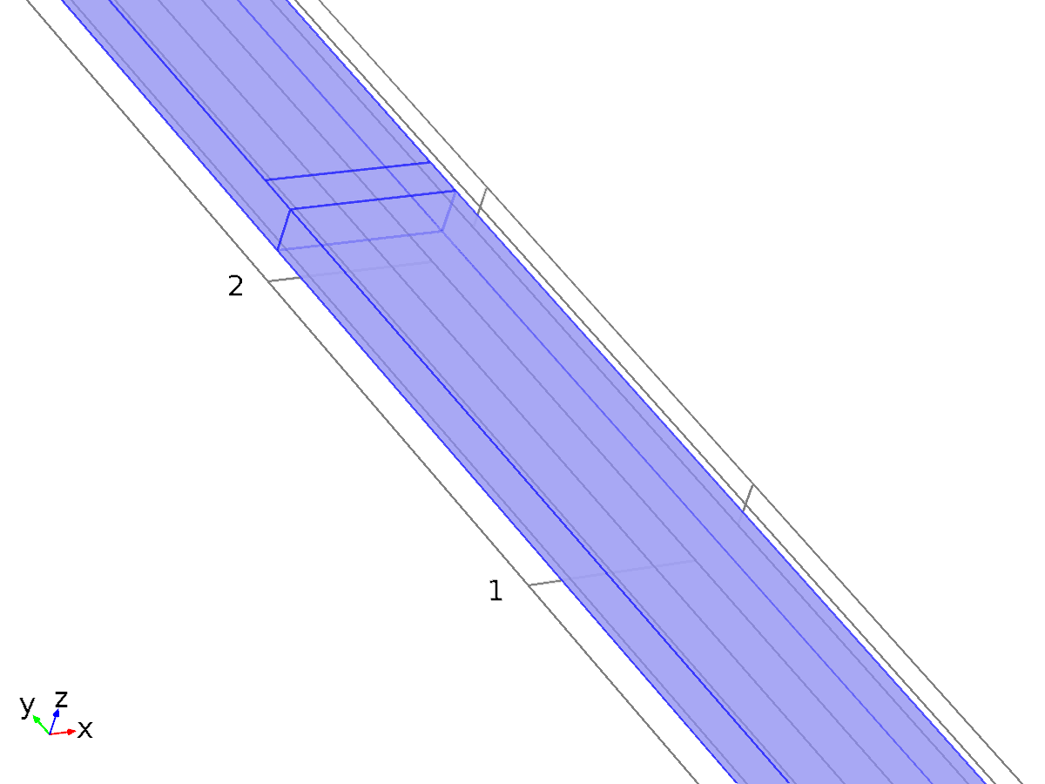
Wall 1
Selection
Geometric entity level | Boundary
Selection | Boundaries 1, 3–5, 7–9, 11–12

Equations
Settings
Description | Value
Boundary condition | No slip
Apply reaction terms on | Individual dependent variables
Use weak constraints | Off
Constraint method | Elemental

Variables
Name | Expression | Unit | Description | Selection
spf.ubndx | 0 | m/s | Velocity at boundary, x component | Boundaries 1, 3–5, 7–9, 11–12
spf.ubndy | 0 | m/s | Velocity at boundary, y component | Boundaries 1, 3–5, 7–9, 11–12
spf.ubndz | 0 | m/s | Velocity at boundary, z component | Boundaries 1, 3–5, 7–9, 11–12

Shape functions
Constraint | Constraint force | Shape function | Selection
-u+spf.ubndx | test(-u) | Lagrange (Linear) | Boundaries 1, 3–5, 7–9, 11–12
-v+spf.ubndy | test(-v) | Lagrange (Linear) | Boundaries 1, 3–5, 7–9, 11–12
-w+spf.ubndz | test(-w) | Lagrange (Linear) | Boundaries 1, 3–5, 7–9, 11–12

    - Initial Values 1
Initial Values 1
Selection
Geometric entity level | Domain
Selection | Domains 1–2

Settings
Description | Value
Velocity field, x component | 0
Velocity field, y component | 0
Velocity field, z component | 0
Pressure | 0

Variables
Name | Expression | Unit | Description | Selection
spf.u_initx | 0 | m/s | Velocity field, x component | Domains 1–2
spf.u_inity | 0 | m/s | Velocity field, y component | Domains 1–2
spf.u_initz | 0 | m/s | Velocity field, z component | Domains 1–2
spf.p_init | 0 | Pa | Pressure | Domains 1–2

    - Inlet 1
Inlet 1
Selection
Geometric entity level | Boundary
Selection | Boundary 2

Equations
Settings
Description | Value
Boundary condition | Velocity
Velocity field componentwise | Normal inflow velocity
Normal inflow velocity | v_in
Use weak constraints | Off
Apply reaction terms on | All physics (symmetric)
Constraint method | Elemental

Variables
Name | Expression | Unit | Description | Selection
spf.ubndx | -nojac(spf.nxmesh)*spf.U0in | m/s | Velocity at boundary, x component | Boundary 2
spf.ubndy | -nojac(spf.nymesh)*spf.U0in | m/s | Velocity at boundary, y component | Boundary 2
spf.ubndz | -nojac(spf.nzmesh)*spf.U0in | m/s | Velocity at boundary, z component | Boundary 2
spf.U0in | v_in | m/s | Normal inflow velocity | Boundary 2
spf.d_ux | 1 | 1 | Inflow velocity direction, x component | Boundary 2
spf.d_uy | 0 | 1 | Inflow velocity direction, y component | Boundary 2
spf.d_uz | 0 | 1 | Inflow velocity direction, z component | Boundary 2

Shape functions
Constraint | Constraint force | Shape function | Selection
-u+spf.ubndx | test(-u+spf.ubndx) | Lagrange (Linear) | Boundary 2
-v+spf.ubndy | test(-v+spf.ubndy) | Lagrange (Linear) | Boundary 2
-w+spf.ubndz | test(-w+spf.ubndz) | Lagrange (Linear) | Boundary 2

    - Outlet 1
Outlet 1
Selection
Geometric entity level | Boundary
Selection | Boundary 10

Equations
Settings
Description | Value
Boundary condition | Pressure
Pressure | 0
Normal flow | Off
Suppress backflow | On
Use weak constraints | Off
Apply reaction terms on | All physics (symmetric)
Constraint method | Elemental

Variables
Name | Expression | Unit | Description | Selection
spf.p0 | 0 | Pa | Pressure | Boundary 10
spf.f0 | spf.p0+spf.uNormal*(spf.backflowPenaltyDiff-spf.backflowPenaltyConv)*(spf.uNormal<0) | N/m^2 | Normal stress | Boundary 10
spf.uNormal | u*nojac(spf.nxmesh)+v*nojac(spf.nymesh)+w*nojac(spf.nzmesh) | m/s | Normal velocity | Boundary 10
spf.c_here | 144/spf.epsilon_p | 1 | Intermediate variable | Boundary 10
spf.meshVolInt | down(meshvol) |  | Volume of interior mesh element | Boundary 10
spf.meshVol | meshvol |  |  | Boundary 10
spf.backflowPenaltyDiff | spf.c_here*min((down(spf.mu)+spf.muT)*spf.meshVol/spf.meshVolInt,down(spf.rho)*abs(spf.uNormal)/down(spf.epsilon_p)) |  | Backflow penalty parameter, diffusive contribution | Boundary 10
spf.rhoFace | down(spf.rho) | kg/m^3 | Density face value | Boundary 10
spf.umxTnFace | spf.upwind_helpx*spf.nxmesh+spf.upwind_helpy*spf.nymesh+spf.upwind_helpz*spf.nzmesh | m/s | Relative velocity on face | Boundary 10
spf.backflowPenaltyConv | spf.rhoFace*spf.umxTnFace/spf.epsilon_p^2 | kg/(m^2*s) | Backflow penalty parameter, convective contribution | Boundary 10
spf.upwind_ns | spf.backflowPenaltyConv*spf.uNormal | Pa | Upwind term | Boundary 10
spf.out1.Mflow | spf.out1.intFlow(spf.rho*(spf.nx*u+spf.ny*v+spf.nz*w)) | kg/s | Mass flow | Global

Weak expressions
Weak expression | Integration frame | Selection
-spf.f0*(test(u)*spf.nxmesh+test(v)*spf.nymesh+test(w)*spf.nzmesh) | Material | Boundary 10

  - Mesh 1
Mesh statistics
Description | Value
Minimum element quality | 0.03636
Average element quality | 0.5332
Tetrahedral elements | 25600
Prism elements | 13000
Triangular elements | 6740
Quadrilateral elements | 180
Edge elements | 458
Vertex elements | 14

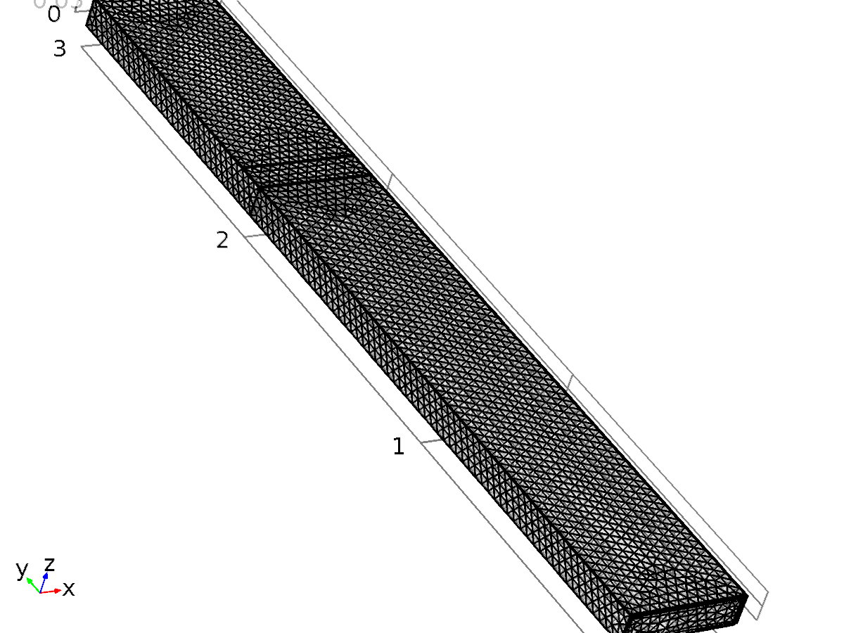
Mesh 1
    - Size (size)
Settings
Description | Value
Calibrate for | Fluid dynamics
Maximum element size | 0.0865
Minimum element size | 0.0183
Resolution of narrow regions | 0.3
Maximum element growth rate | 1.4
Predefined size | Extremely coarse

    - Size 1 (size1)
Selection
Geometric entity level | Boundary
Selection | Boundaries 1, 3–5, 7–9, 11–12

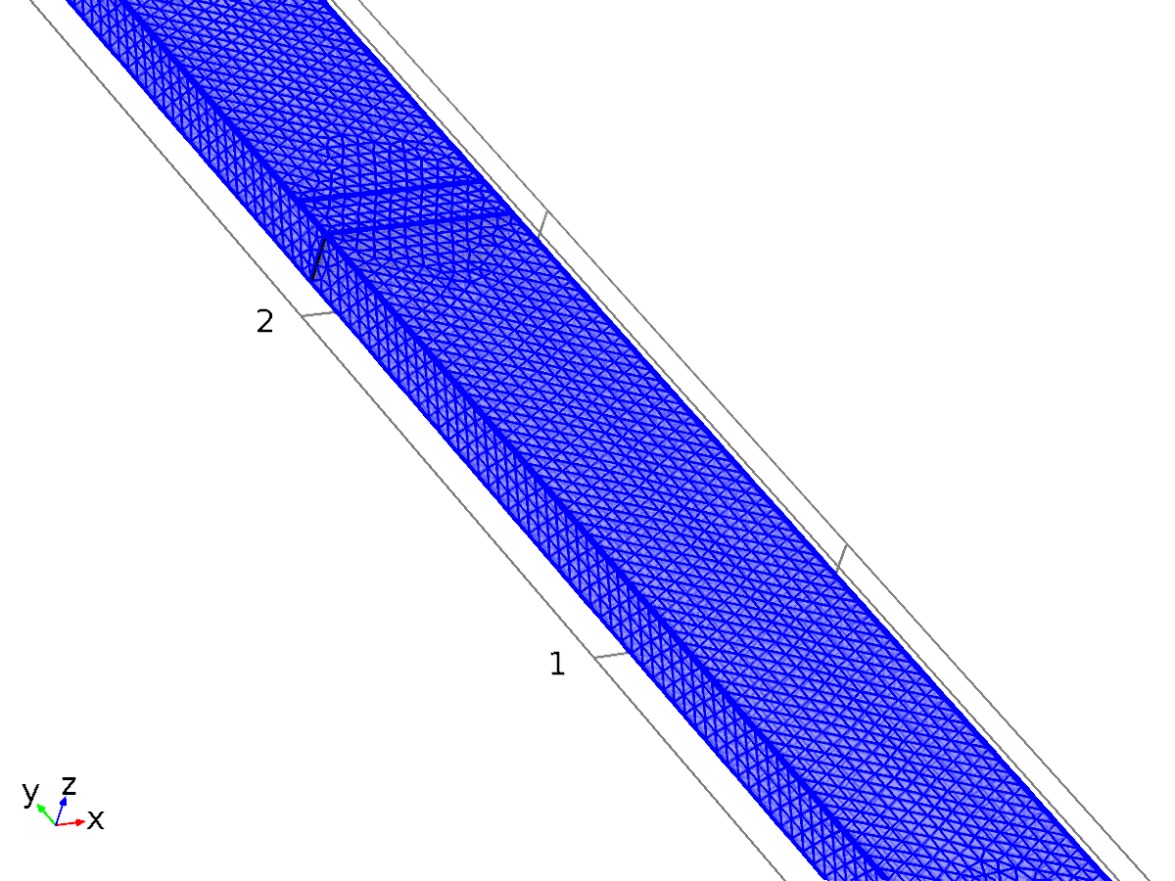
Size 1
Settings
Description | Value
Calibrate for | Fluid dynamics
Maximum element size | 0.0341
Minimum element size | 0.0105
Curvature factor | 0.8
Resolution of narrow regions | 0.5
Maximum element growth rate | 1.25
Predefined size | Coarser

    - Corner Refinement 1 (cr1)
Selection
Geometric entity level | Domain
Selection | Domains 1–2

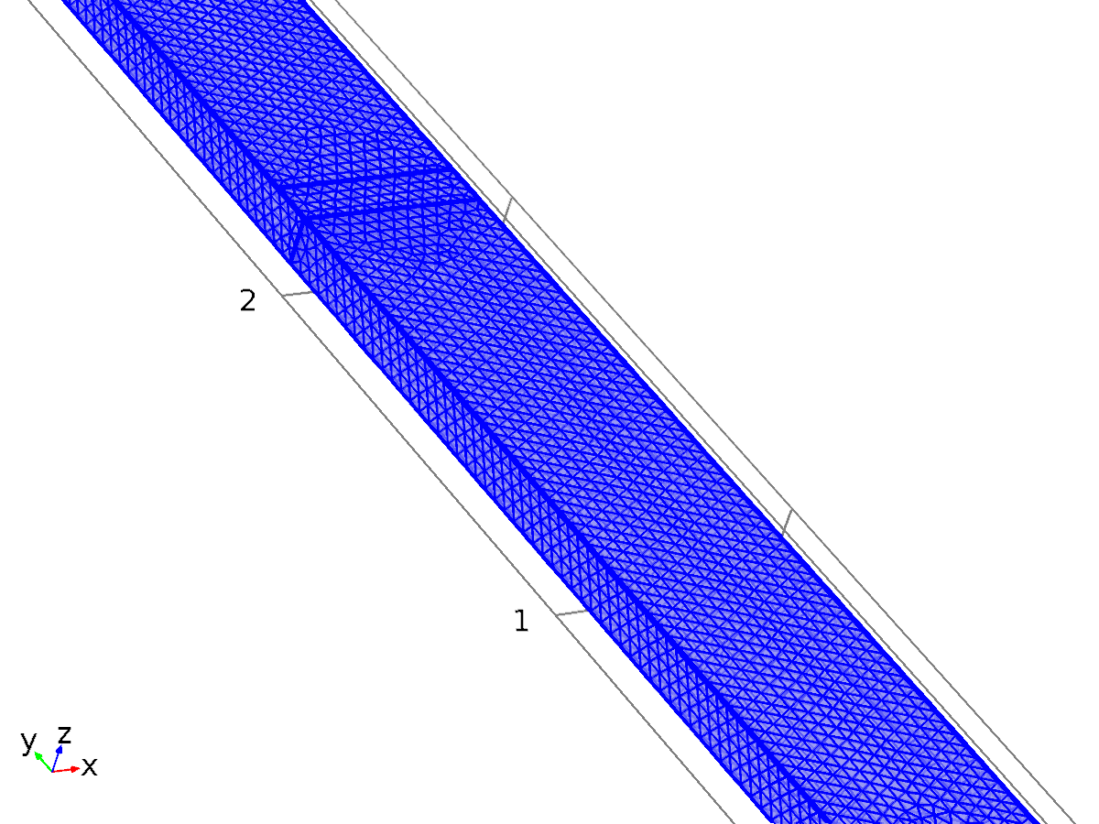
Corner Refinement 1
    - Free Tetrahedral 1 (ftet1)
Selection
Geometric entity level | Remaining

    - Boundary Layers 1 (bl1)
Selection
Geometric entity level | Domain
Selection | Domains 1–2

Boundary Layers 1
Settings
Description | Value
Handling of sharp edges | Trimming

Boundary Layer Properties 1 (blp1)
Selection
Geometric entity level | Boundary
Selection | Boundaries 1, 3–5, 7–9, 11–12

Boundary Layer Properties 1
Settings
Description | Value
Number of boundary layers | 2
Thickness adjustment factor | 5

- Study 1
Computation information
Computation time | 5 min 57 s
CPU | Intel(R) Core(TM) i5-4460 CPU @ 3.20GHz, 4 cores
Operating system | Windows 7

  - Cyclic Voltammetry
Study settings
Description | Value
Include geometric nonlinearity | Off

Physics and variables selection
Physics interface | Discretization
Electroanalysis (elan) | physics

Mesh selection
Geometry | Mesh
Geometry 1 (geom1) | mesh1

  - Solver Configurations
    - Solution 2

Compile Equations: Cyclic Voltammetry (st1)
Study and step
Description | Value
Use study | Study 1
Use study step | Cyclic Voltammetry

Dependent Variables 1 (v1)
General
Description | Value
Defined by study step | Cyclic Voltammetry

Initial values of variables solved for
Description | Value
Solution | Zero

Values of variables not solved for
Description | Value
Method | Solution
Solution | Solution 1

Concentration (comp1.cOx) (comp1_cOx)
General
Description | Value
Field components | comp1.cOx

Concentration (comp1.cRex) (comp1_cRex)
General
Description | Value
Field components | comp1.cRex

Pressure (comp1.p) (comp1_p)
General
Description | Value
Field components | comp1.p
Solve for this field | Off

Velocity field (comp1.u) (comp1_u)
General
Description | Value
Field components | {comp1.u, comp1.v, comp1.w}
Solve for this field | Off

Time-Dependent Solver 1 (t1)
General
Description | Value
Defined by study step | Cyclic Voltammetry
Time | {0, 10000}
Relative tolerance | 0.05

Absolute tolerance: Concentration (comp1.cOx)
Description | Value
Method | Scaled
Tolerance | 1e-4

Absolute tolerance: Concentration (comp1.cRex)
Description | Value
Method | Scaled
Tolerance | 1e-4

Time stepping
Description | Value
Initial step | 0.05[s]
Initial step | On
Maximum step | 50[s]
Maximum step | On
Maximum BDF order | 2

Results while solving
Description | Value
Plot | On
Plot group | Cyclic Voltammograms (elan)

Output
Description | Value
Times to store | Steps taken by solver

Log
Time-Dependent Solver 1 in Solution 2 started at 25-Jun-2015 14:05:39.
Time-dependent solver (BDF)
Number of degrees of freedom solved for: 25216 (plus 8302 internal DOFs).
Nonsymmetric matrix found.
Scales for dependent variables:
Concentration (comp1.cOx): 0.39
Concentration (comp1.cRex): 0.95
Step Time Stepsize Res Jac Sol Order Tfail NLfail LinIt LinErr LinRes
0 0 - out 2 3 2 0 6 0.017 6.4e-005
1 0.05 0.05 out 3 4 3 1 0 0 7 3.3e-005 6.1e-007
2 0.1 0.05 out 4 5 4 1 0 0 8 8.5e-005 1.2e-006
3 0.2 0.1 out 5 6 5 2 0 0 9 9e-005 8.9e-007
4 0.4 0.2 out 6 7 6 2 0 0 10 0.00097 1.2e-005
5 0.8 0.4 out 7 8 7 2 0 0 11 0.0033 1.5e-005
6 1.6 0.8 out 8 9 8 1 0 0 12 0.0014 2.1e-005
7 3.2 1.6 out 9 10 9 1 0 0 13 0.00063 3.2e-006
8 6.4 3.2 out 10 11 10 1 0 0 14 0.0012 7.7e-006
9 12.8 6.4 out 12 12 12 1 0 0 17 0.038 0.00018
10 14.4 1.6 out 16 14 16 1 1 0 31 0.015 3e-005
11 16 1.6 out 18 15 18 1 1 0 36 0.035 9.3e-005
12 17.211 1.2113 out 20 16 20 1 1 0 40 0.031 8.2e-005
13 18.186 0.97458 out 22 17 22 1 1 0 45 0.041 0.00017
14 18.998 0.81242 out 24 18 24 1 1 0 53 0.026 0.0002
15 19.727 0.72881 out 26 19 26 1 1 0 59 0.018 4e-005
16 20.383 0.65592 out 28 20 28 1 1 0 65 0.023 7.7e-005
17 20.973 0.59033 out 30 21 30 1 1 0 73 0.028 0.00032
18 21.564 0.59033 out 32 22 32 1 1 0 79 0.024 5.3e-005
19 22.154 0.59033 out 34 23 34 1 1 0 87 0.02 4.9e-005
20 22.744 0.59033 out 36 24 36 2 1 0 90 0.029 8.1e-005
21 23.925 1.1807 out 38 25 38 2 1 0 96 0.043 9.3e-005
22 24.876 0.95102 out 40 26 40 2 1 0 100 0.025 5.2e-005
23 25.827 0.95102 out 42 27 42 2 1 0 106 0.024 5.5e-005
24 26.778 0.95102 out 44 28 44 2 1 0 112 0.025 7.6e-005
25 27.729 0.95102 out 46 29 46 2 1 0 118 0.016 4.8e-005
26 28.68 0.95102 out 48 30 48 2 1 0 124 0.027 6.8e-005
27 30.582 1.902 out 50 31 50 2 1 0 137 0.016 4e-005
28 32.229 1.6466 out 52 32 52 2 1 0 148 0.027 5.4e-005
29 33.575 1.3461 out 54 33 54 2 1 0 156 0.035 8e-005
30 34.921 1.3461 out 56 34 56 1 1 0 164 0.023 4.2e-005
31 36.267 1.3461 out 58 35 58 1 1 0 171 0.043 0.00015
32 38.959 2.6922 out 60 36 60 1 1 0 180 0.036 0.00013
33 44.344 5.3844 out 62 37 62 1 1 0 192 0.017 4.1e-005
34 49.728 5.3844 out 66 38 66 1 1 0 221 0.047 0.0004
35 60.497 10.769 out 68 39 68 1 1 0 228 0.021 3.5e-005
36 63.189 2.6922 out 72 41 72 1 2 0 252 0.023 7.2e-005
37 66.438 3.249 out 76 43 76 1 3 0 266 0.037 9.4e-005
38 68.313 1.8749 out 80 45 80 1 4 0 279 0.027 6e-005
39 70.188 1.8749 out 82 46 82 1 4 0 286 0.028 6.6e-005
40 71.771 1.5825 out 84 47 84 1 4 0 294 0.031 0.00013
41 73.173 1.4023 out 86 48 86 1 4 0 302 0.026 6.3e-005
42 74.575 1.4023 out 88 49 88 1 4 0 310 0.011 3.3e-005
43 75.977 1.4023 out 90 50 90 1 4 0 317 0.011 2.6e-005
44 77.38 1.4023 out 93 51 93 1 4 0 326 0.023 5.5e-005
45 78.214 0.83416 out 99 53 99 1 5 0 346 0.02 6.7e-005
46 79.048 0.83416 out 102 54 102 1 5 0 359 0.02 0.00019
47 79.799 0.75074 out 105 55 105 1 5 0 368 0.019 4.3e-005
48 80.474 0.67567 out 108 56 108 1 5 0 380 0.017 5.5e-005
49 81.083 0.6081 out 111 57 111 1 5 0 393 0.037 0.00043
50 81.691 0.6081 out 114 58 114 1 5 0 402 0.026 9.6e-005
51 82.238 0.54729 out 117 59 117 1 5 0 410 0.022 0.00019
52 82.785 0.54729 out 119 60 119 1 5 0 421 0.035 0.00065
53 83.333 0.54729 out 122 61 122 1 5 0 435 0.023 0.00029
54 83.88 0.54729 out 124 62 124 1 5 0 447 0.035 0.0014
55 84.372 0.49256 out 126 63 126 1 5 0 454 0.044 0.0014
56 84.865 0.49256 out 128 64 128 1 5 0 465 0.048 0.0013
57 84.988 0.12314 out 135 66 135 1 5 1 501 0.011 3.7e-005
58 85.111 0.12314 out 137 67 137 1 5 1 504 0.044 0.00017
59 85.234 0.12314 out 139 68 139 1 5 1 507 0.038 0.00014
60 85.358 0.12314 out 141 69 141 1 5 1 510 0.037 0.00013
61 85.604 0.24628 out 143 70 143 1 5 1 514 0.021 5.5e-005
62 85.85 0.24628 out 145 71 145 1 5 1 518 0.023 5.9e-005
63 86.052 0.20151 out 147 72 147 1 5 1 522 0.016 4e-005
64 86.253 0.20151 out 149 73 149 1 5 1 526 0.015 3.7e-005
65 86.455 0.20151 out 151 74 151 1 5 1 530 0.015 3.7e-005
66 86.858 0.40303 out 153 75 153 1 5 1 535 0.049 0.00011
67 87.208 0.34997 out 155 76 155 1 5 1 540 0.046 0.00012
68 87.519 0.31097 out 157 77 157 1 5 1 545 0.037 0.00017
69 87.83 0.31097 out 159 78 159 1 5 1 550 0.038 0.0003
70 88.141 0.31097 out 161 79 161 1 5 1 555 0.04 0.00054
71 88.451 0.31097 out 163 80 163 1 5 1 560 0.043 0.00096
72 89.073 0.62194 out 165 81 165 2 5 1 568 0.021 0.00027
73 89.695 0.62194 out 167 82 167 2 5 1 582 0.025 0.00031
74 90.255 0.55974 out 169 83 169 2 5 1 592 0.041 0.00074
75 90.815 0.55974 out 171 84 171 2 5 1 609 0.045 0.0014
76 91.375 0.55974 out 174 85 174 2 5 1 630 0.027 0.00032
77 91.934 0.55974 out 176 86 176 2 5 1 652 0.036 0.00055
78 92.438 0.50377 out 178 87 178 2 5 1 671 0.027 0.009
79 92.942 0.50377 out 180 88 180 2 5 1 687 0.046 0.035
80 93.446 0.50377 out 183 89 183 2 5 1 708 0.049 0.077
81 93.949 0.50377 out 185 90 185 2 5 1 731 0.046 0.13
82 93.964 0.014678 out 193 94 193 1 8 1 773 0.0035 1.9e-005
83 93.974 0.0096096 out 197 96 197 1 9 1 781 0.013 6.3e-005
84 93.982 0.0086486 out 199 97 199 1 9 1 784 0.0038 2e-005
85 93.991 0.0086486 out 201 98 201 1 9 1 786 0.003 1.9e-005
86 94 0.0086486 out 203 99 203 1 9 1 788 0.0027 1.5e-005
87 94.008 0.0086486 out 205 100 205 1 9 1 790 0.0028 1.6e-005
88 94.026 0.017297 out 207 101 207 2 9 1 793 0.0038 2.5e-005
89 94.043 0.017297 out 209 102 209 2 9 1 796 0.0066 4.3e-005
90 94.06 0.017297 out 211 103 211 2 9 1 798 0.0042 3.6e-005
91 94.077 0.017297 out 213 104 213 2 9 1 800 0.0031 2.2e-005
92 94.095 0.017297 out 215 105 215 2 9 1 802 0.0024 1.3e-005
93 94.112 0.017297 out 217 106 217 2 9 1 804 0.0018 1.1e-005
94 94.147 0.034594 out 219 107 219 2 9 1 807 0.012 6.8e-005
95 94.181 0.034594 out 221 108 221 2 9 1 810 0.027 0.00014
96 94.216 0.034594 out 223 109 223 2 9 1 813 0.0092 4.6e-005
97 94.25 0.034594 out 225 110 225 2 9 1 816 0.004 1.8e-005
98 94.285 0.034594 out 227 111 227 2 9 1 819 0.0039 1.7e-005
99 94.32 0.034594 out 229 112 229 2 9 1 822 0.0035 1.5e-005
100 94.354 0.034594 out 231 113 231 2 9 1 824 0.0046 2.4e-005
101 94.389 0.034594 out 233 114 233 2 9 1 826 0.0036 1.9e-005
102 94.423 0.034594 out 235 115 235 2 9 1 828 0.003 1.6e-005
103 94.458 0.034594 out 237 116 237 2 9 1 830 0.0028 1.3e-005
104 94.527 0.069189 out 239 117 239 2 9 1 833 0.022 8.2e-005
105 94.589 0.06227 out 241 118 241 2 9 1 836 0.027 0.0001
106 94.652 0.06227 out 243 119 243 2 9 1 839 0.011 4e-005
107 94.714 0.06227 out 245 120 245 2 9 1 842 0.0088 3.1e-005
108 94.776 0.06227 out 247 121 247 2 9 1 845 0.0071 2.5e-005
109 94.839 0.06227 out 249 122 249 2 9 1 848 0.0042 1.5e-005
110 94.901 0.06227 out 251 123 251 2 9 1 851 0.0037 1.3e-005
111 94.963 0.06227 out 253 124 253 2 9 1 853 0.006 2.3e-005
112 95.088 0.12454 out 255 125 255 2 9 1 856 0.026 8.5e-005
113 95.2 0.11209 out 257 126 257 2 9 1 859 0.031 0.00011
114 95.312 0.11209 out 259 127 259 2 9 1 862 0.014 3.7e-005
115 95.424 0.11209 out 261 128 261 2 9 1 865 0.013 3.4e-005
116 95.536 0.11209 out 263 129 263 2 9 1 868 0.0074 2.6e-005
117 95.648 0.11209 out 265 130 265 2 9 1 871 0.0056 1.5e-005
118 95.76 0.11209 out 267 131 267 2 9 1 874 0.0047 1.4e-005
119 95.872 0.11209 out 269 132 269 2 9 1 877 0.0042 1.2e-005
120 96.096 0.22417 out 271 133 271 2 9 1 881 0.023 7.2e-005
121 96.321 0.22417 out 273 134 273 2 9 1 885 0.02 5.1e-005
122 96.522 0.20175 out 275 135 275 1 9 1 890 0.029 7e-005
123 96.696 0.17359 out 277 136 277 1 9 1 893 0.047 0.00012
124 96.87 0.17359 out 279 137 279 1 9 1 896 0.04 8.9e-005
125 97.043 0.17359 out 281 138 281 1 9 1 899 0.039 7.9e-005
126 97.217 0.17359 out 283 139 283 1 9 1 902 0.036 7.8e-005
127 97.564 0.34718 out 285 140 285 2 9 1 906 0.04 8.5e-005
128 97.798 0.23404 out 289 142 289 1 10 1 915 0.016 3.6e-005
129 97.998 0.19971 out 291 143 291 1 10 1 919 0.033 6.5e-005
130 98.197 0.19971 out 293 144 293 1 10 1 923 0.034 5.5e-005
131 98.397 0.19971 out 295 145 295 1 10 1 926 0.028 7e-005
132 98.796 0.39942 out 297 146 297 1 10 1 932 0.017 4.7e-005
133 99.156 0.35948 out 299 147 299 1 10 1 937 0.042 9.1e-005
134 99.479 0.32353 out 301 148 301 1 10 1 942 0.022 0.00012
135 99.803 0.32353 out 303 149 303 1 10 1 947 0.019 0.00026
136 100.13 0.32353 out 305 150 305 1 10 1 952 0.018 0.00055
137 100.45 0.32353 out 307 151 307 1 10 1 957 0.029 0.0011
138 100.77 0.32353 out 309 152 309 2 10 1 963 0.012 7.2e-005
139 101.1 0.32353 out 311 153 311 2 10 1 968 0.011 7e-005
140 101.42 0.32353 out 313 154 313 2 10 1 972 0.014 0.0001
141 102.07 0.64706 out 315 155 315 2 10 1 980 0.048 0.00086
142 102.62 0.55285 out 317 156 317 2 10 1 995 0.036 0.00084
143 103.17 0.55285 out 319 157 319 2 10 1 1012 0.045 0.00061
144 103.73 0.55285 out 321 158 321 2 10 1 1028 0.045 0.00087
145 104.28 0.55285 out 323 159 323 2 10 1 1048 0.035 0.00057
146 104.83 0.55285 out 325 160 325 2 10 1 1060 0.05 0.00052
147 105.38 0.55285 out 327 161 327 2 10 1 1071 0.049 0.00068
148 105.94 0.55285 out 329 162 329 2 10 1 1082 0.045 0.00092
149 106.49 0.55285 out 331 163 331 2 10 1 1092 0.043 0.001
150 107.04 0.55285 out 333 164 333 2 10 1 1103 0.042 0.0011
151 107.6 0.55285 out 336 165 336 2 10 1 1116 0.048 0.0015
152 108.15 0.55285 out 338 166 338 2 10 1 1129 0.045 0.0018
153 108.7 0.55285 out 340 167 340 2 10 1 1139 0.038 0.0021
154 109.25 0.55285 out 342 168 342 2 10 1 1150 0.044 0.002
155 109.81 0.55285 out 344 169 344 2 10 1 1159 0.045 0.0019
156 110.36 0.55285 out 346 170 346 2 10 1 1168 0.044 0.0017
157 110.91 0.55285 out 348 171 348 2 10 1 1173 0.048 0.0018
158 111.47 0.55285 out 350 172 350 2 10 1 1181 0.046 0.0016
159 112.02 0.55285 out 352 173 352 2 10 1 1189 0.047 0.0015
160 112.57 0.55285 out 354 174 354 2 10 1 1198 0.043 0.0014
161 113.12 0.55285 out 356 175 356 2 10 1 1206 0.042 0.0014
162 113.68 0.55285 out 358 176 358 2 10 1 1214 0.041 0.0016
163 114.23 0.55285 out 360 177 360 2 10 1 1222 0.04 0.0015
164 114.78 0.55285 out 362 178 362 2 10 1 1227 0.042 0.0015
165 115.34 0.55285 out 364 179 364 2 10 1 1234 0.042 0.0015
166 115.89 0.55285 out 366 180 366 2 10 1 1239 0.024 0.0011
167 116.44 0.55285 out 368 181 368 2 10 1 1245 0.042 0.0027
168 116.99 0.55285 out 370 182 370 2 10 1 1250 0.013 0.00022
169 117.55 0.55285 out 372 183 372 2 10 1 1255 0.011 0.0001
170 118.1 0.55285 out 374 184 374 2 10 1 1261 0.027 0.0016
171 118.65 0.55285 out 376 185 376 2 10 1 1266 0.011 0.00022
172 119.21 0.55285 out 378 186 378 2 10 1 1271 0.0095 5.3e-005
173 119.76 0.55285 out 380 187 380 2 10 1 1276 0.011 0.00013
174 120.31 0.55285 out 382 188 382 2 10 1 1281 0.015 0.00018
175 120.86 0.55285 out 384 189 384 2 10 1 1285 0.05 0.00014
176 121.42 0.55285 out 386 190 386 2 10 1 1289 0.047 0.00013
177 121.97 0.55285 out 388 191 388 2 10 1 1293 0.045 0.00012
178 122.52 0.55285 out 390 192 390 2 10 1 1297 0.041 0.00011
179 123.08 0.55285 out 392 193 392 2 10 1 1301 0.036 8.9e-005
180 124.18 1.1057 out 394 194 394 2 10 1 1306 0.034 6.9e-005
181 125.18 0.99512 out 396 195 396 2 10 1 1312 0.034 7.1e-005
Stop condition fulfilled at t = 125.18 (elan (Cyclic voltammetry)).
Time-Dependent Solver 1 in Solution 2: Solution time: 350 s (5 minutes, 50 seconds)
Physical memory: 2.22 GB
Virtual memory: 2.23 GB

Stop Condition 1 (st1)
Stop expressions
Stop expression | Stop if | Active | Description
comp1.elan.stopcond | True (>=1) | On | elan (Cyclic voltammetry)

Stop events
Description | Value
Implicit event

Output at stop
Description | Value
Add solution | Steps before and after stop
Add warning | Off

Fully Coupled 1 (fc1)
General
Description | Value
Linear solver | Iterative 1

Method and termination
Description | Value
Jacobian update | Once per time step
Maximum number of iterations | 5

Iterative 1 (i1)
General
Description | Value
Factor in error estimate | 40
Maximum number of iterations | 400

Multigrid 1 (mg1)
General
Description | Value
Use hierarchy in geometries | Geometry 1

Presmoother (pr)

SOR Line 1 (sl1)
Main
Description | Value
Relaxation factor | 0.2

Secondary
Description | Value
Relaxation factor | 0.4

Postsmoother (po)

SOR Line 1 (sl1)
Main
Description | Value
Relaxation factor | 0.2

Secondary
Description | Value
Number of secondary iterations | 2
Relaxation factor | 0.4

Coarse Solver (cs)

Direct 1 (d1)
General
Description | Value
Solver | PARDISO

- Study 2
Computation information
Computation time | 22 s
CPU | Intel(R) Core(TM) i5-4460 CPU @ 3.20GHz, 4 cores
Operating system | Windows 7

  - Stationary
Study settings
Description | Value
Include geometric nonlinearity | Off

Physics and variables selection
Physics interface | Discretization
Laminar Flow (spf) | physics

Mesh selection
Geometry | Mesh
Geometry 1 (geom1) | mesh1

  - Solver Configurations
    - Solution 1

Compile Equations: Stationary (st1)
Study and step
Description | Value
Use study | Study 2
Use study step | Stationary

Dependent Variables 1 (v1)
General
Description | Value
Defined by study step | Stationary

Initial values of variables solved for
Description | Value
Method | Solution
Solution | Solution 2

Values of variables not solved for
Description | Value
Solution | Zero

Concentration (comp1.cOx) (comp1_cOx)
General
Description | Value
Field components | comp1.cOx
Solve for this field | Off

Concentration (comp1.cRex) (comp1_cRex)
General
Description | Value
Field components | comp1.cRex
Solve for this field | Off

Pressure (comp1.p) (comp1_p)
General
Description | Value
Field components | comp1.p

Velocity field (comp1.u) (comp1_u)
General
Description | Value
Field components | {comp1.u, comp1.v, comp1.w}

Stationary Solver 1 (s1)
General
Description | Value
Defined by study step | Stationary

Log
Stationary Solver 1 in Solution 1 started at 25-Jun-2015 13:22:27.
Nonlinear solver
Number of degrees of freedom solved for: 50432.
Nonsymmetric matrix found.
Scales for dependent variables:
Pressure (comp1.p): 12
Velocity field (comp1.u): 12
Orthonormal null-space function used.
Iter SolEst ResEst Damping Stepsize #Res #Jac #Sol LinErr LinRes
1 0.01 1.1e+003 0.0100000 0.01 2 1 2 9.3e-013 1.6e-015
2 0.0084 1e+003 0.1000000 0.0095 3 2 4 1.1e-012 1.6e-015
3 0.0018 25 1.0000000 0.0081 4 3 6 4.9e-013 1.4e-014
4 0.0015 0.79 1.0000000 0.012 5 4 8 6.5e-012 2e-015
5 0.00034 0.1 1.0000000 0.0016 6 5 10 1.5e-012 3.7e-015
Stationary Solver 1 in Solution 1: Solution time: 14 s
Physical memory: 2.59 GB
Virtual memory: 2.61 GB

Fully Coupled 1 (fc1)
General
Description | Value
Linear solver | Direct 1

Method and termination
Description | Value
Initial damping factor | 0.01
Minimum damping factor | 1.0E-6

Direct 1 (d1)
General
Description | Value
Solver | PARDISO

- Results
  - Data Sets
    - No Solution
Solution
Description | Value
Solution | None
Component | Geometry 1

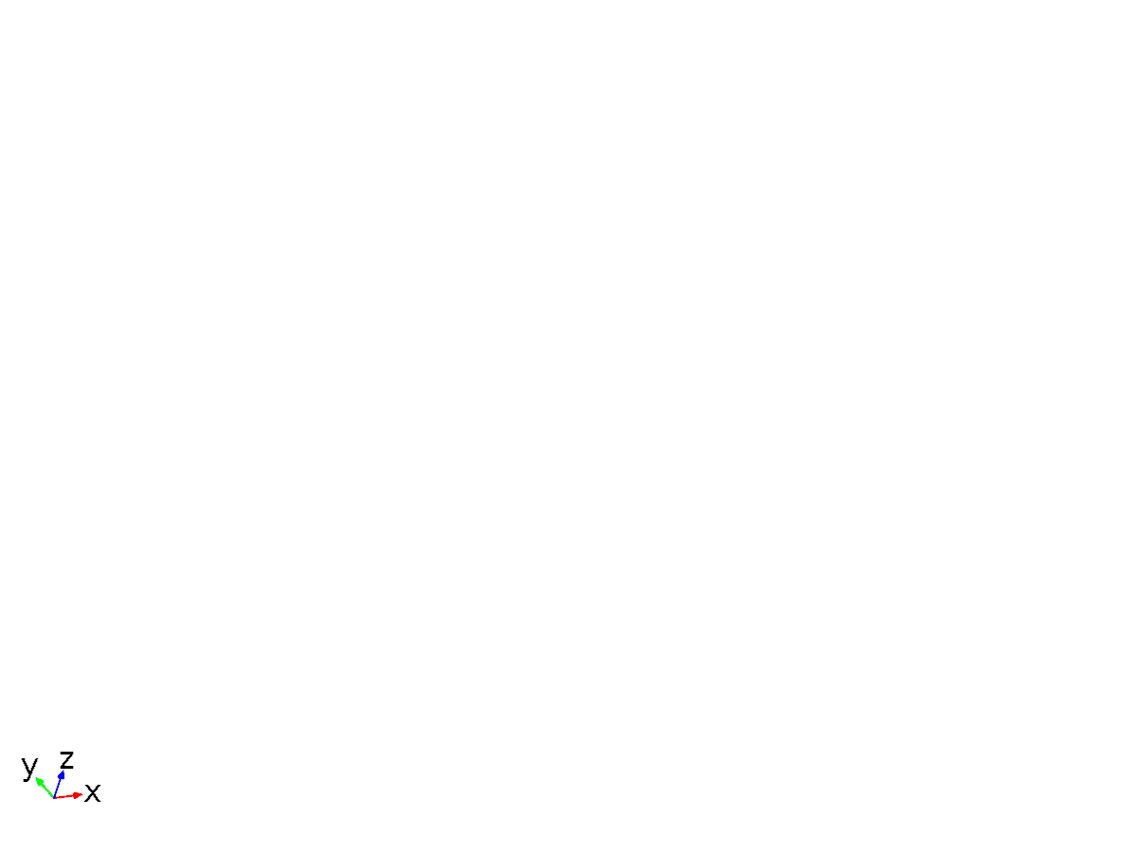
Data set: No Solution
    - Cut Plane 1
Data
Description | Value
Data set | No Solution

Plane data
Description | Value
Plane type | Quick
x-coordinate | 0

Advanced
Description | Value
Space variables | {cpl1x, cpl1y}

Data set: Cut Plane 1
    - Study 2/Solution 1
Solution
Description | Value
Solution | Solution 1
Component | Save Point Geometry 1

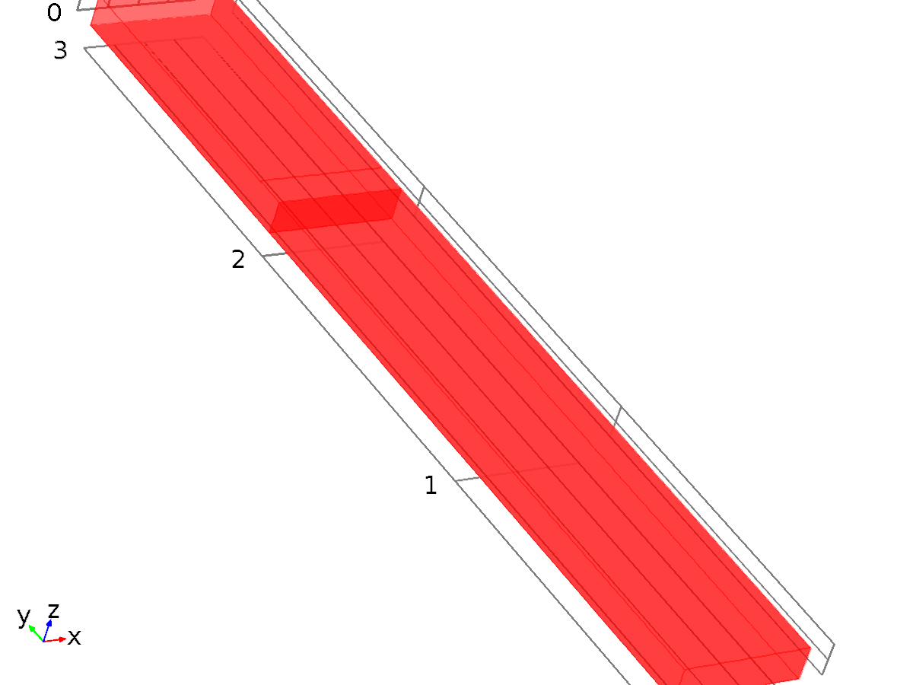
Data set: Study 2/Solution 1
    - Surface 1
Data
Description | Value
Data set | Study 2/Solution 1

Parameterization
Description | Value
x- and y-axes | Surface parameters

    - Surface 2
Data
Description | Value
Data set | Study 2/Solution 1

Parameterization
Description | Value
x- and y-axes | Surface parameters

    - Study 1/Solution 2
Solution
Description | Value
Solution | Solution 2
Component | Save Point Geometry 1

Data set: Study 1/Solution 2
  - Plot Groups
    - Cyclic Voltammograms (elan)
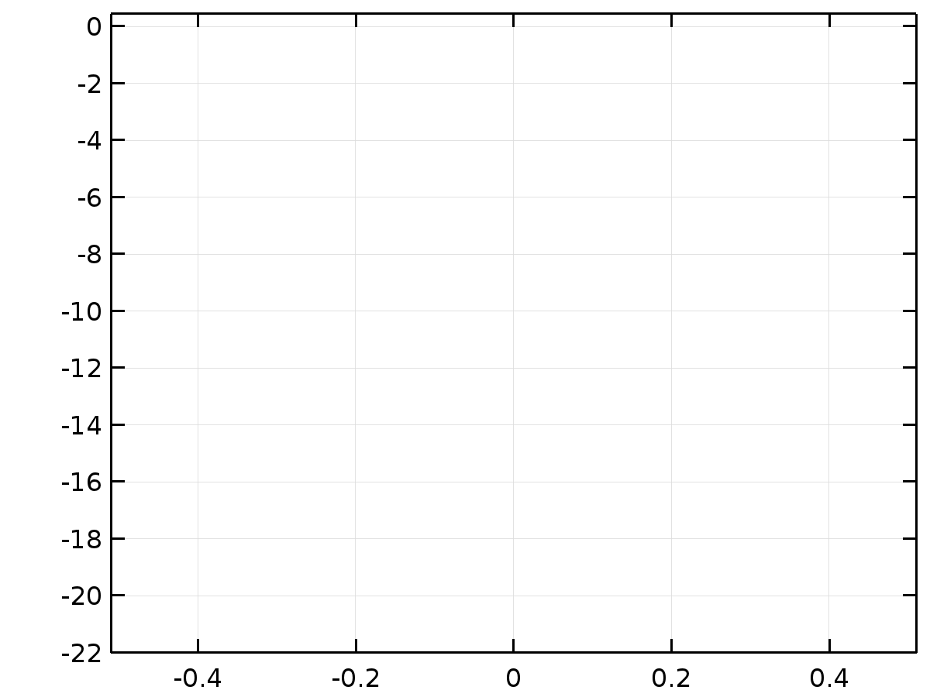
    - Velocity (spf)
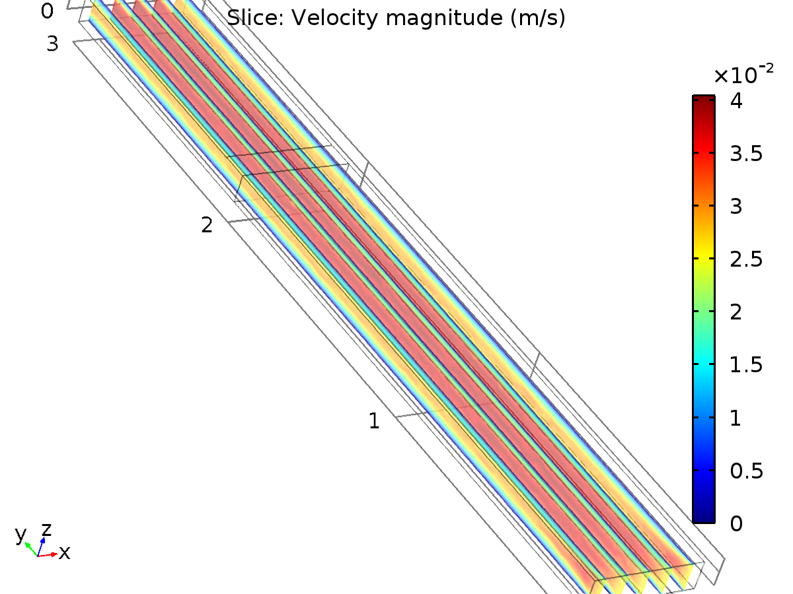
Slice: Velocity magnitude (m/s)
    - Pressure (spf)
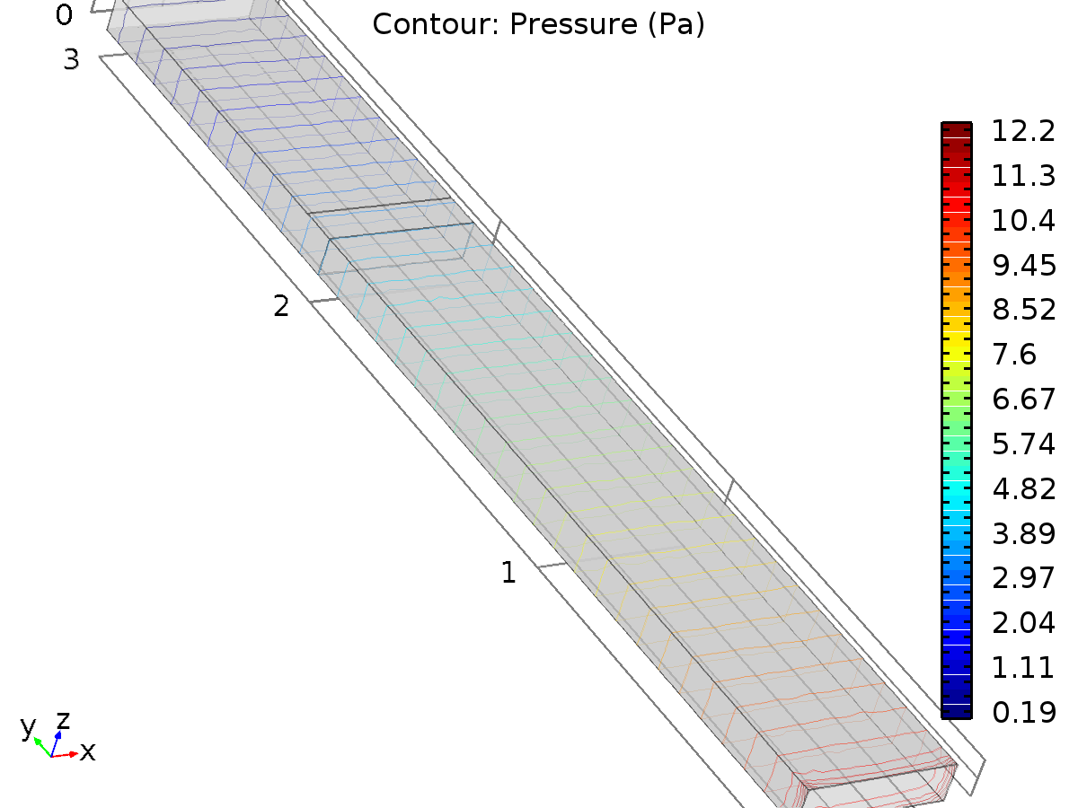
Contour: Pressure (Pa)
    - Cyclic Voltammograms (elan) 1
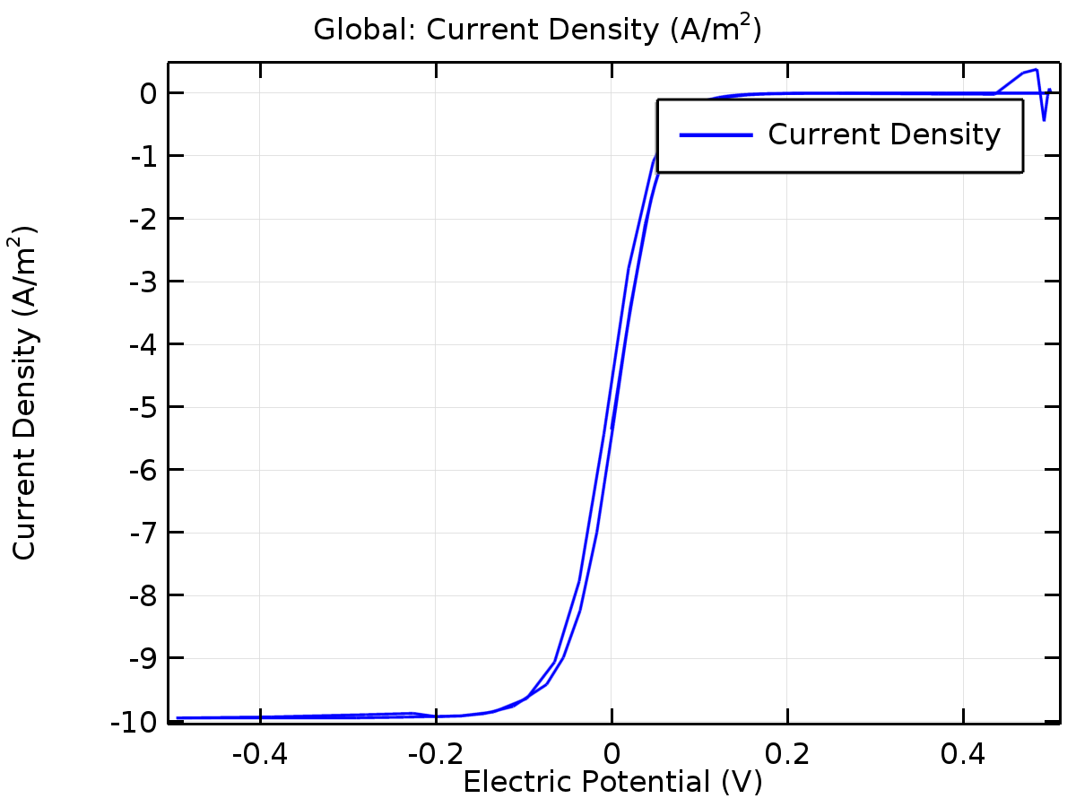
Global: Current Density (A/m²)
    - Electrode Potential (elan)
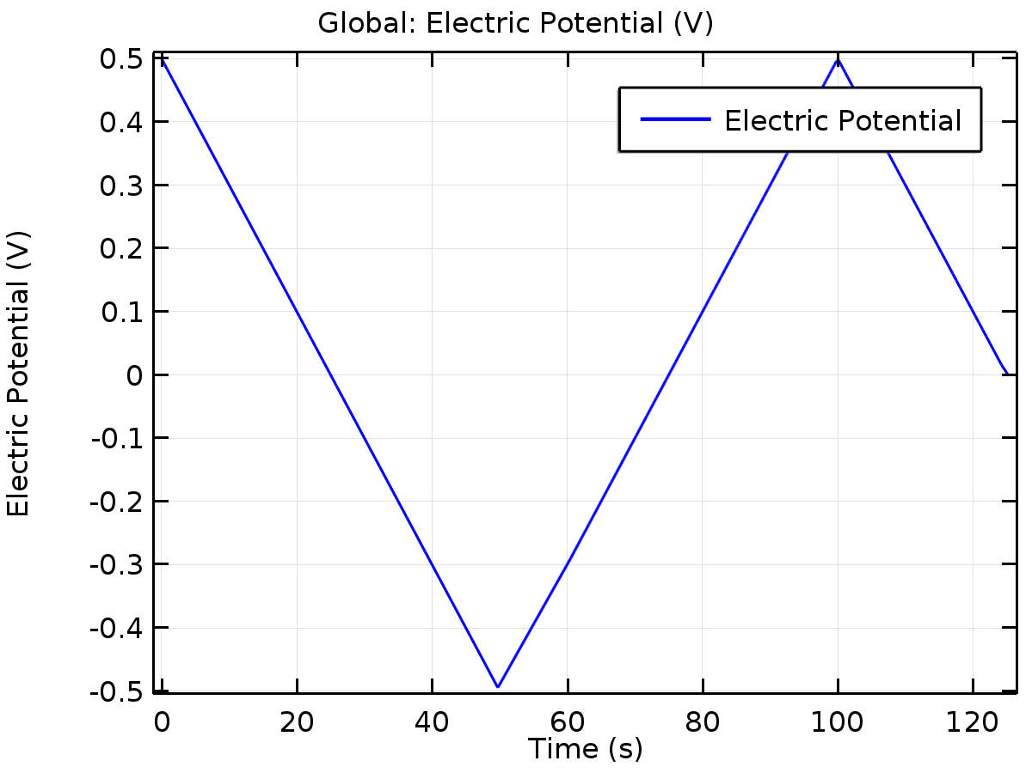
Global: Electric Potential (V)
    - Average Current Density (elan)
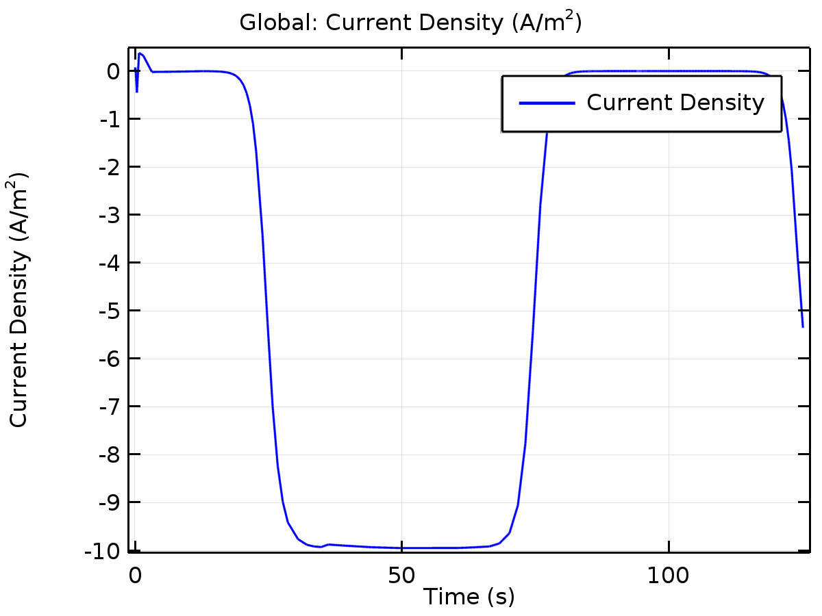
Global: Current Density (A/m²)
    - Concentration (elan)
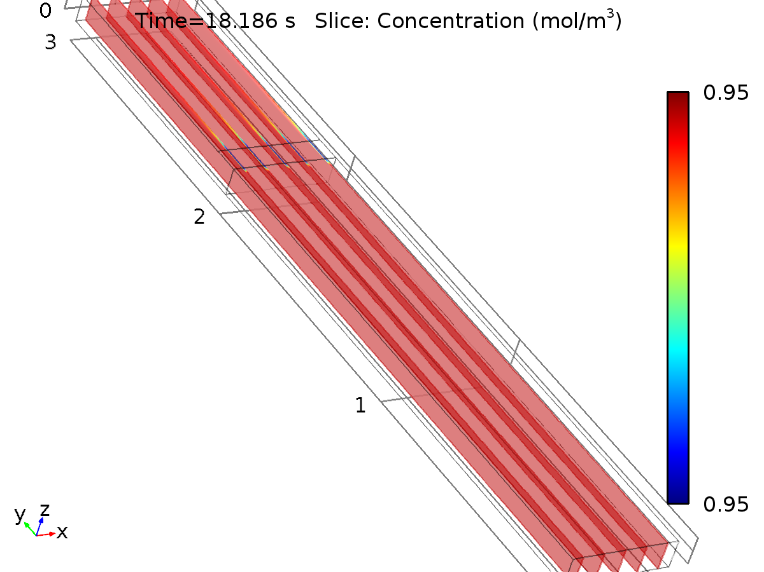
Time=18.186 s Slice: Concentration (mol/m³)
    - Concentration (elan) 1
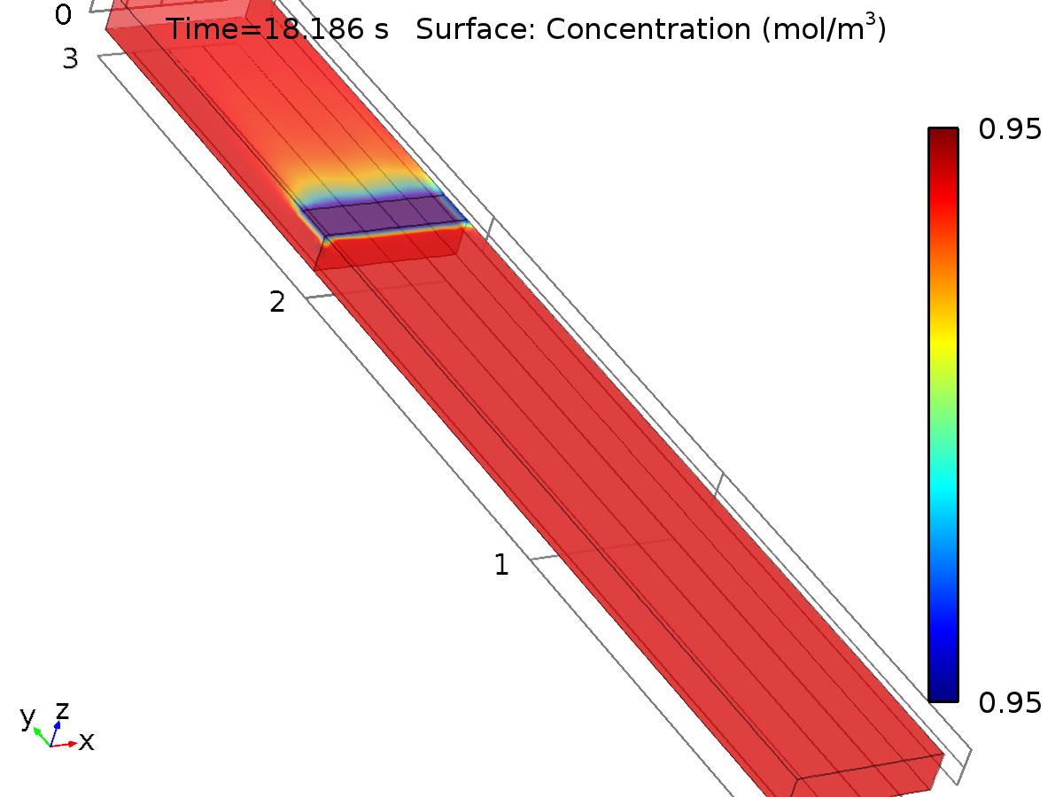
Time=18.186 s Surface: Concentration (mol/m³)

