COMSOL Simple Heat Transfer Test
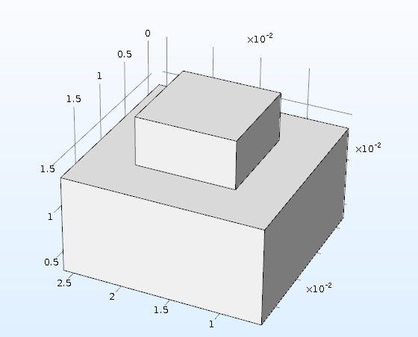
The top block is a 10x10x5 mm and made of Silicon Carbide
The bottom block is 20x20x10 mm and made of Copper

