● Purpose : Simulation of heart valve model .
● Problem : Comsol don't recognize self-made valve for simulation.
● Present setup
- model wizard - 3D – Laminar flow – time dependent
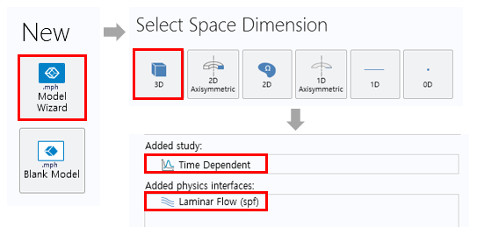

1. Process
- Heart and valve models are implemented separately and then combined.
- Uncheck simplify mesh of CAD file and import.
- If set to Form a union, an error occurs, set to Form a assembly.
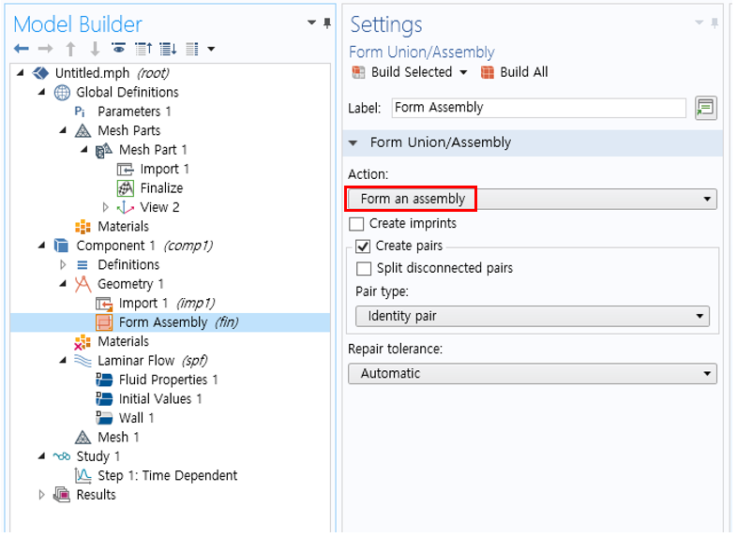

- Set the imported model to detect boundaries as boundary partitioning of mesh part.
- Modify the detect angle at detect boundaries to set the boundaries of the mesh.
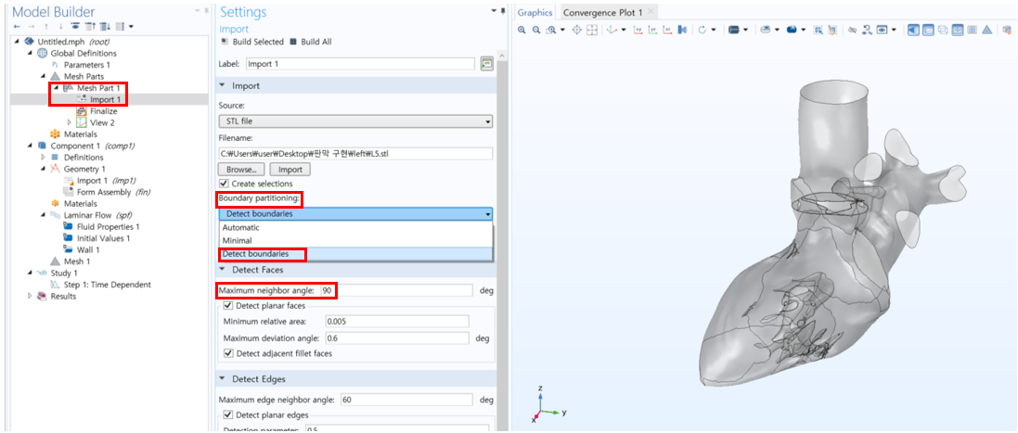

- meterials setting : density = 1055 kg/m^3, dynamic viscosity = 0.0035 Pa·s
- boundary condition setting : Pulmonary vein=inlet, Aorta=outlet, etc=wall
- mesh setting : Separately set the mesh size of the heart and valve
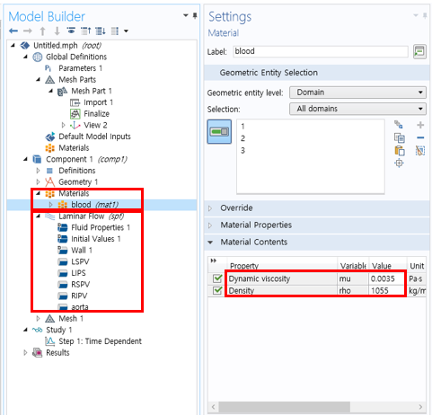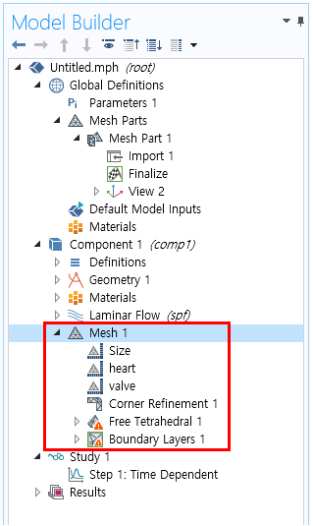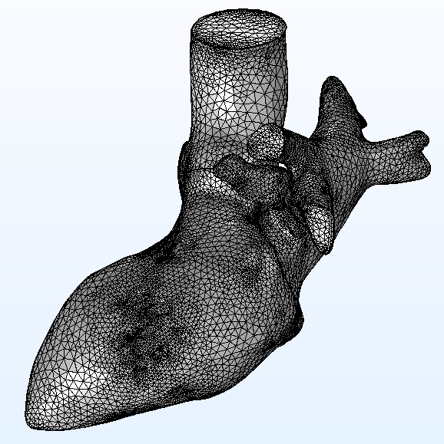

2. Problem
- Compute after completing materials, boundary conditions, and mesh settings, it will appear as follows.
- Currently used model is MV(mitral valve) close, AV(aortic valve) open.
- The MV is in close condition, but the stream line is created by passing through the blocked valve.
- Streamline should be formed only in the open part of AV, but the whole is created.
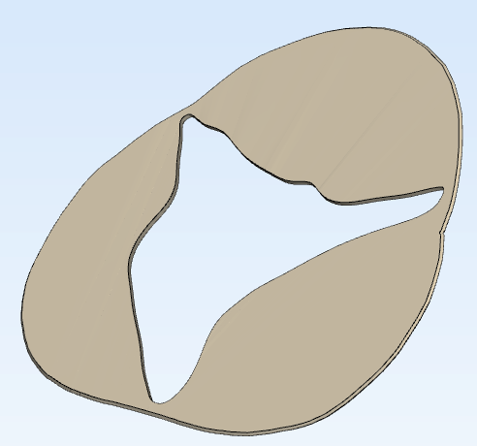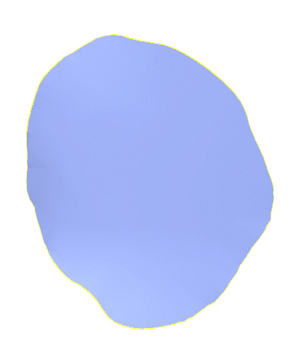
[AV] [MV]

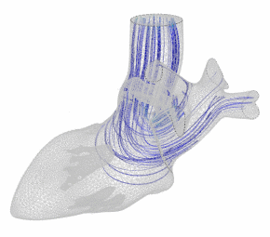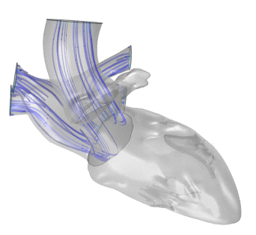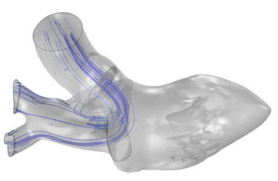
MV
AV
MV
AV
AV
MV
[streamline]

3. Solution investigation
- If interior wall is set, valves in the model are recognized and streamlines are expected to not flow.
- But can't set interior wall.
