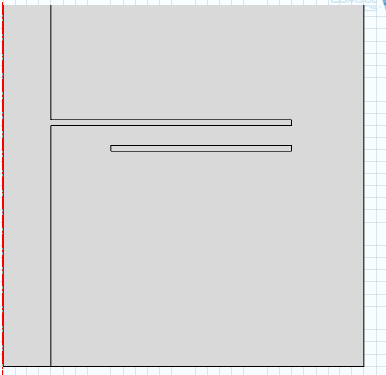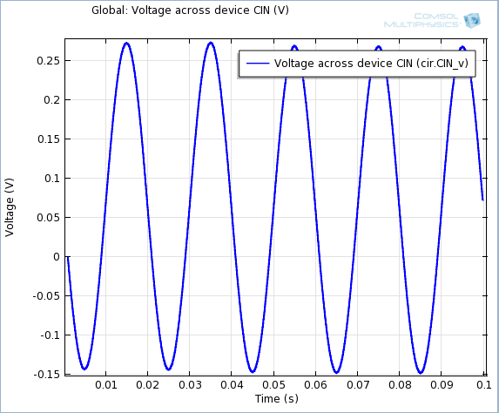
- EC
Terminal 2 ( circuit)
- Electric circuit
- External I Vs. U 1 { (none 1
0)
Terminal voltage (ec/term 2)}
- Capacitor{ (none 0
1)
1.0 E ^{– 6} F
- Ground (none 0)

- EC
Terminal 1
10000*sin(2*pi*50*t[1/s])
I did not understand for what the output voltage is not symmetrical
and what does not has a voltage of 1V is ready (as calculated theoretical value)?
Diviseur capacitif :
Vm
C1
C2
Ve

with :
Vm =1V ; C2=1µF ; Ve= 10 kV.
On à:
$$Vs=\frac{C1 .Ve}{C1+C2}$$
therefore
C 1= 100 pF

